# 

**GIS**

**and**

**Remote Sensing**

**Volume 3**





Using QGIS and Landsat Images to Monitor Seasonal Crop Development

Robert Catherman

Director of Safe Water Development - MEDRIX™

May 2019

Edition E-3-8



**GIS and**

**Remote Sensing**

**Volume 3**

Using QGIS and Landsat Images

to Monitor Seasonal Crop Development

Robert Catherman

Director of Safe Water Development - MEDRIX™

May 2019

Edition E-3-8

|  |  |
| --- | --- |
|  |  |

*Preface*

This curriculum is the third in a series of five volumes on the topic of using QGIS open source software. The intended purpose of these volumes is to provide detailed instructions that can be used as curriculum in GIS classes. Special attention has been paid to English syntax so the text can be easily translated into other languages. Currently the text is available in English and Vietnamese.

Volume One is an introduction to QGIS open source software intended for the first-time user of GIS software.

Volume Two introduces the use of QGIS for analyzing forest coverage changes using Landsat remote sensed images.

This volume, the third in the series, is intended for users having basic familiarity with the use of GIS software but who are not necessarily proficient in using QGIS. The instructions in this volume will direct the learner using a case study that follows the growth of a corn crop from planting through harvesting by analyzing selected Landsat images.

Volume Four teaches the use of QGIS software for analyzing land use and land coverage characteristics by classifying values in remote sensed images according to patterns of interest to the user.

Volume Five teaches the use of QGIS software and System Dynamics modeling software (Vensim) for exploring topics in the ecology of water. The curriculum will explore issues such as flow patterns, droughts, flooding, salinity intrusion, sea-level rise and climate change impacts. This volume is still being written as of May 2019.

*Acknowledgments*

Dr. Joe Hannah, formerly of the faculty of the Geography Department at University of Washington, my instructor in GEOG 360 who taught me principles of map making and how to effectively use GIS technology as well as shared frequent consultations over coffee during the development of this project.

Dr. Miles G. Logsdon, Senior Lecturer, School of Oceanography, College of Ocean and Fishery Sciences, University of Washington, Seattle, WA introduced me to the use of remote sensed images in OCN 452.

Jeff Hawk, drone pilot

Andy Werkhoven, dairyman and corn farmer

2019 University of Washington, Geography Department students who tested and edited the curriculum in Geography 469, Capstone class: Andrew Baker, Jesse Flores, Jody Nguyen Tran, Jayna Wang.

**(CC BY-NC 4.0)**

This is a human-readable summary of (and not a substitute for) the [license](https://creativecommons.org/licenses/by-nc/4.0/legalcode). [Disclaimer](https://creativecommons.org/licenses/by-nc/4.0/).

**You are free to:**

* **Share** — copy and redistribute the material in any medium or format
* **Adapt** — remix, transform, and build upon the material
* The licensor cannot revoke these freedoms as long as you follow the license terms.

**Under the following terms:**

* **Attribution** — You must give [appropriate credit](https://creativecommons.org/licenses/by-nc/4.0/), provide a link to the license, and [indicate if changes were made](https://creativecommons.org/licenses/by-nc/4.0/). You may do so in any reasonable manner, but not in any way that suggests the licensor endorses you or your use.
* **NonCommercial** — You may not use the material for [commercial purposes](https://creativecommons.org/licenses/by-nc/4.0/).

**No additional restrictions** — You may not apply legal terms or [technological measures](https://creativecommons.org/licenses/by-nc/4.0/) that legally restrict others from doing anything the license permits.

***The***

***Contents***

1

Part 1: General Principles of Remote Sensing 3

Chapter 1: About Remote Sensing 4

Chapter 2: Defining the Project 5

Part 2: Creating Maps Using GIS 7

Chapter 3: Installing QGIS and 7-Zip 8

Chapter 4: Locating GIS Maps 11

Chapter 5: Defining a Study Area and Reference Map 12

Part 3: Adding Remote Sensed Data in GIS 20

Chapter 6: Locating Remote Sensed Data 21

Chapter 7: Acquiring Remote Sensed Data 24

Part 4: Analyzing Remote Sensed Data 28

Chapter 8: Image Interpretation 29

Chapter 9: Normalized Difference Vegetation Index (NDVI) 31

Chapter 10: Applying NDVI Analysis 40

Chapter 11: Ground Truth Sampling 43

Chapter 12: Analyzing Images during the Growing Season 47

Chapter 13: Sampling Point Data 54

Chapter 14: Final Analysis and Conclusions 58

Chapter 16: Printing Maps and Images 59

Chapter 17: Telling the Story 66

Part 5: Useful Tools 67

Chapter 18: Creating a Study Area Using Google Earth 68

Chapter 19: Adding Photos to a Map 72

Chapter 20: Using Model Builder 74

Chapter 21: Looking for Clouds 78

Appendixes: 81

Appendix A: References 81

Appendix B: NDVI ColorRamps 82

Appendix C: Landsat Image Specifications 83

Index 84

# Part 1: General Principles of Remote Sensing

## Chapter 1: About Remote Sensing

This chapter includes:

* Description of the study of remote sensing

**Definition:** Remote sensing is the science of deriving information about an object from measurements made at a distance from that object.

**Examples of methods of acquiring remote-sensed data:** aerial photography, satellite-captured images, RADAR, LIDAR, etc.

**Uses of remote sensing:** agriculture crop monitoring, forestry management, weather forecasting, military intelligence, urban planning, mapping, and many other fields.

**Equipment used for remote sensing:** satellites, airplanes, drones, cameras, GPS, computers, and a variety of other devices.

**Software used in remote sensing:** GIS software, Google Earth, internet websites, computer data archives of images, etc.

It is important to understand that many components of the remote sensing process act as parts of a system and cannot be isolated from one another.

For a more complete understanding of remote sensing, a search of the Internet will uncover many sources of current information. An instructional course, either online or at a local university, will develop understanding and provide hands-on opportunities to work with remote-sensed data.

It is not the intent of this text to develop a thorough understanding of remote sensing. Instead, the purpose of this text is to give the student step-by-step instructions for using GIS software to acquire and manipulate remote-sensed data. By completing the case study in this text, the student will develop a basic understanding of some of the processes involved in analyzing remote-sensed data and learn to draw conclusions from that analysis. Hopefully, this text will motivate students towards a more in-depth study of this interesting and expanding field.

It also is not the intent of this text to be a tutorial on the use of GIS software or, specifically, QGIS, the most popular open source GIS software in use at the time of writing. Although this text will guide the student through the steps of using QGIS to process remote-sensed images, explanations regarding the functions of GIS are brief. Again, an online class or university course is needed to gain a full understanding of GIS software.

## Chapter 2: Defining the Project

This chapter includes:

* Description of the study project and its goals

During the growing season of 2018, I observed the changes in a corn field near Monroe, Washington, USA. I watched the crop as it developed from seeds planted in bare earth to sprouted shoots to maturity and, finally, to harvest.

This project will examine satellite images acquired by Landsat satellites to determine how the vegetation coverage of this corn field changed during the 2018 growing season as “observed” using satellite data.

You can use the skills developed in this course to monitor a crop development project of your own. You should look for an area to monitor the development of a crop that is important to the economy of your local region.

Multiple steps are needed to study the changes over time that can be observed and analyzed related to this project:

First, the location of the crop field needs to be identified by parameters consistent with Landsat image georeferencing. Latitude and longitude coordinates can be determined by GPS.

Next, view the area using Google Earth using the field’s latitude and longitude. Comparing visible imagery from Google Earth and satellite images helps visualize pattern correlation between difference types of remotely sensed images.

Analyze Landsat images using the NDVI analysis method.

Practice ground truthing to verify information in your study.

Combine GIS and other software tools to visualize the data collected in your study.

Finally, draw some conclusions from your various observations.

QGIS - define study area (5)

QGIS - create reference map (5)

Download Landsat images (7)

QGIS - load Landsat images (8)

QGIS - perform NDVI analysis (10-13)

QGIS - print maps (14)

Download Admin maps (4)

Ground Truthing (15)

Download QGIS software (3)

# 

# Part 2: Creating Maps Using GIS

## 

## Chapter 3: Installing QGIS and 7-Zip

This chapter includes:

* Instructions to download and install QGIS
* Instructions to download and install 7-Zip for uncompressing files

**Step 1: QGIS Installation for Windows PC**

Time to complete: 10-20 minutes (depends on your download speed)

Download QGIS from this website:

<http://www.qgis.org/en/site/forusers/download.html>

Choose **QGIS** **Standalone Installer Version 3.6**. or later

To see whether your computer has a 32 or 64 bit processor go to **Control Panel > System** and view the “System type” in the **System** section.

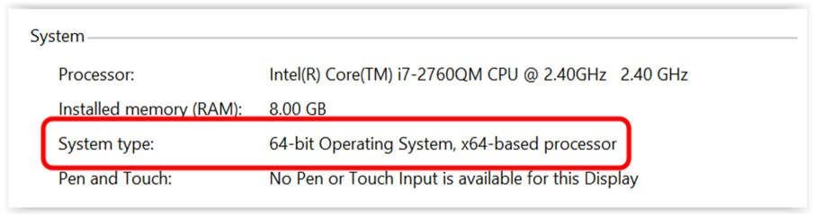

If you are unsure as to whether to install a 32 or 64-bit version of QGIS, select the 32-bit version.

Open the QGIS installer and follow the instructions.

**NOTE:** At the time this curriculum was prepared, the current version of QGIS was 3.6, in April 2019.

Configure the QGIS default options:

Start **QGIS**

On the **QGIS** menu bar

Select **Settings** > **Options**

Select **General** tab

If settings are locked, click the **Override system locale** box on the top left

Select **Style** that corresponds to your computer operating system

Change **Icon Size** to *32*

Change **Font** to *Arial* (or your choice)

Change **Size** to *12* (or your choice)

On the **QGIS** menu bar

Select **View > Toolbars > Manage Layers Toolbar**

To correctly display foreign language characters

Select **Settings > Options > Data Sources**

In the **Data source handling** section

Uncheck the box next to **Ignore shapefile encoding declaration**

**OK**

On the **QGIS** menu bar

Select **Project** > **Exit QGIS**

**Step 2: QGIS Installation for Mac**

Time to complete: 10-20 minutes (depends on your download speed)

Download QGIS from this website:

<http://www.qgis.org/en/site/forusers/download.html>

Choose **QGIS macOS** **Installer Version 3.6**.

Perform same instructions as in Step 1

In addition, this change is needed to solve a bug related to clipping raster files

On the menu bar select **QGIS 3 >** **Preferences > System**

Open **Environment** section

Check box **Use custom variables**

Click on the plus sign

In **Apply** column, select *Append*

In **Variable** column type *PATH*

In **Value** column copy / paste the following text

:/Library/Frameworks/GDAL.framework/Programs: /Library/Frameworks/PROJ.framework/Programs: /Library/Frameworks/SQLite3.framework/Programs:/Library/Frameworks/UnixImageIO.framework/Programs

Click on **OK** box

When you are finished, your screen should look like this:

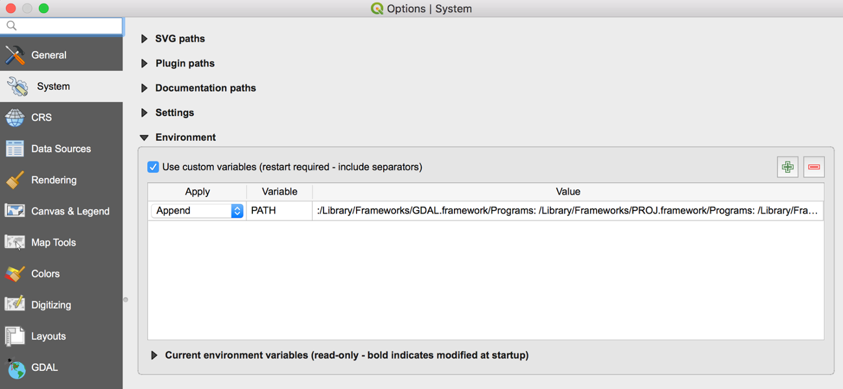

**OK**

On the menu bar select **QGIS 3** > **Quit QGIS 3**

**Step 3. Software Installation - 7-Zip**

For Windows download and install 7-Zip from this website:

<https://www.7-zip.org>

Open the 7-Zip installer and follow the instructions.

Any similar program, such as WinRAR, can be used as well.

For Mac download and install Keka from this website:

https://www.keka.io

Open the Keka installer and follow the instructions.

Then set Keka as the default extraction application using this website:

<https://github.com/aonez/Keka/wiki/Default-application>

Follow instructions under **Set Keka as the Default Extraction Application**

Doing this will help in Chapter 7: Acquiring Remote Sensed Data, Step 4. It will allow Keka to automatically uncompress or extract the downloaded files.

**Step 4. Learning to use QGIS software**

Search the internet for resources for learning QGIS.

One online resource for learning QGIS is <https://foss4geo.wordpress.com/>

## Chapter 4: Locating GIS Maps

This chapter includes:

* Locating appropriate digital maps

One useful source of digital maps for GIS systems is the website for GADM (Database of Global Administrative Areas), which can be accessed at <http://www.gadm.org/>

GADM is a spatial database of the location of the world's administrative areas (or administrative boundaries) for use in GIS software. The coordinate reference system is “latitude/longitude” and uses the datum WGS84. These maps can contain up to 5 levels of administrative subdivisions. A general understanding of the concept of “administrative areas” is presented on Wikipedia at <http://en.wikipedia.org/wiki/Administrative_division>

Other useful sites containing data for roads, rivers, population data, etc.:

<http://www.diva-gis.org/gdata>

https://nationalmap.gov/small_scale/

We will not be using administrative maps in this case study but these references may be useful for other projects

## Chapter 5: Defining a Study Area and Reference Map

This chapter includes:

* Purpose and definition of a study area
* Creating a reference map of the study area

*Note: It is often helpful to see both the instructions in this Word document and the QGIS application on the computer screen at the same time. One way to do this is to “split the screen”. How to split the screen depends on what version of the operating system you are running on your computer. Search the internet for how to split the screen for your version, e.g. “How to split the screen in Windows 10”.*

**Purpose**

The study area gives us some general orientation to the geography around the corn field we plan to monitor. The surrounding characteristics of the study area may provide some helpful clues to aid in our analysis.

We will define our study area by specifying its boundaries. We can define a rectangle by specifying the coordinates of its four corners or we can draw a rectangle of our study area in a map layer of our project.

As we discussed in Chapter 2, the purpose of our study is to analyze satellite remote sensed images to observe changes in vegetation coverage of a corn field near Monroe, Washington, USA, during the 2018 growing season.

**Step 1: Start QGIS**

Start **QGIS**

On the **QGIS** menu bar

Select **Project > New**

**Step 2: Create a folder for this project**

Create a folder on the C: drive for your work - name the folder *GIS Remote Sensing*.

In the *GIS* *Remote Sensing* folder, create a sub-folder named *Monroe.*

On the **QGIS** menu bar

Select **Project** > **Save As**

Browse to the folder *Monroe*

Type **File name** *CropMonitoring*

**Save**

**Step 3: Define the study area**

For our study area, we will use a river valley in Snohomish County in western Washington, USA. The area chosen for this study is a broad, flat river valley where a variety of crops are grown. The most common crops are alfalfa, blue berries and corn for cattle feed. By choosing this area, we can see how the Landsat images depict both the crops and the natural features of the landscape.

Define the corners of our study area by longitude and latitude coordinates. For this study, the boundaries are provided for you using coordinates determined by GPS. For your own projects, you will need to set your own boundaries for your study area.

We will create a vector layer in QGIS using the corners of our study area which are:

Lon,Lat

-122.0242,47.8147

-122.0054,47.7644

-121.9597,47.7651

-121.9581,47.8161

Copy and paste the lines above into a text (.txt) file using Notepad.

For Mac: Copy and paste the lines above into Pages and export as Plain Text (.txt)

Open **Pages**

**File** > **New > Blank**

Copy and Paste the lines above

**File** > **Export to** > **Plain Text**

Select **Next**

Name the file *AreaCornerPoints* and save (for Mac Select **Export**) the file in the folder *Monroe*

On the **QGIS** menu bar

Select **Layer** > **Add Layer > Add Delimited Text Layer**

In **File Name** box

Browse to the folder *Monroe*

Select file *AreaCornerPoints*

**Open**

On the **File Format** box

Select *CSV*

In the **Record and Fields Options** box

Select *0* in **Number of header lines to discard**

Select check markin box next to **First record has field names**

On the **Geometry Definition** box

Select *Point Coordinates*

In the **Geometry CRS** box

Select *Project CRS:ESPG:4326 WGS 84*

**Add**

**Close**

**Step 4: Create a new shapefile layer**

On the **QGIS** menu bar

Select **Layer**

Select **Create Layer > New Shapefile Layer**

Choose **Geometry Type** *Polygon*

In the **CRS** box

Click on the globe icon at the end of the CRS line 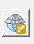

In the **Filter** box, type *10N*

In the **Coordinate reference systems of the world**

Select *WGS 84 / UTM zone 10N*

**OK > OK**

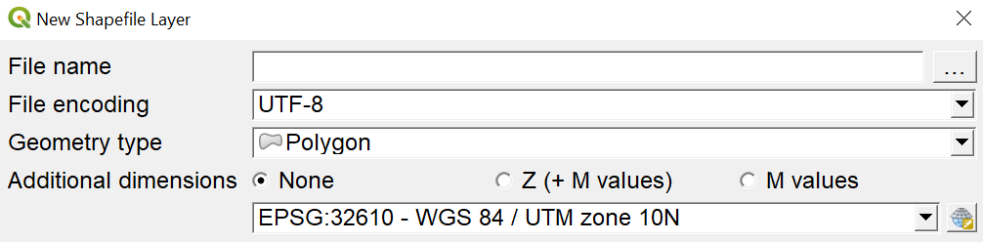

Each shapefile has an attribute table where data about its features can be stored. Add any attribute fields you want in the **New Attribute** section. Adding fields is optional; fields can always be added later

In **New Field** box

In **Name** box type *Name*

Select *Text* *data* in **Type** box

In **Length** box type *48*

Click onthe **Add to fields list** button

In **File Name** box, browse to the folder*Monroe*

Type **File Name** *StudyArea*

**Save**

**OK**

Your new *StudyArea* layer will automatically be added to the navigation menu on the left of your screen. In addition, the shapefile named *StudyArea* will now be saved in the folder *Monroe*.

**Step 5: Draw the boundaries of your study area**

On the **QGIS** menu bar

Select **View** > **Toolbars** > Select *check mark* for **Digitizing Toolbar**

Right click on the layer *AreaCornerPoints*

Select **Zoom to Layer**

Left click on the *StudyArea* layer

Select the **Toggle Editing** icon 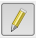 on the toolbar to turn editing “on”

Select the **Add Polygon Feature** icon  on toolbar

Draw a polygon around your study area

Position the cursor at the upper left point of your area and left click

Move the cursor to the upper right point of your area and left click

Move the cursor to the lower right point of your area and left click

Move the cursor to the lower left point of your area and left click

Right click to finish the polygon

Your polygon will disappear, this is OK

Type number “*1*” in the **id** box

Type *Corners* in the **Name** box

**OK**

Select the **Toggle Editing** icon  on the toolbar to turn editing “off”

**Save**

Right click the *StudyArea* layer > **Properties**

Select **Symbology** tab

Click on **Simple Fill**

For **Fill style** select *No Brush*

For **Stroke color** select *red* > **OK**

For **Stroke width** type *1*

For **Stroke style** select *solid line*

**Apply** > **OK**

**Step 6: Adjust the boundaries of your study area**

If you want to adjust the shape of your study area

Left click on the *StudyArea* layer

Select the **Toggle Editing** icon  on the toolbar to turn editing “on”

Select the **Vertex Tool** icon 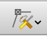 on the toolbar

(the cursor will change to a cross +)

Move the “cross” cursor over the corner point you want to move

Click left mouse button to select the point then release the mouse button

Move the cursor to a new location

Click the left mouse button to reposition the point

When you are finished moving the corner points of your Study Area polygon

Select **Toggle Editing** icon on the toolbar to turn editing “off”

**Save**

**Step 7: Save the Project**

The new shapefile named *StudyArea* defining your study area has been saved in folder *Monroe*.

Delete the CSV layer *AreaCornerPoints*

Right click on the layer *AreaCornerPoints*

Select **Remove Layer > OK**

On the **QGIS** menu bar

Select **Project** > **Save**

The vector shapefile named *StudyArea* can now be used to “clip” images, so they only contain data for the defined study area. More about this later.

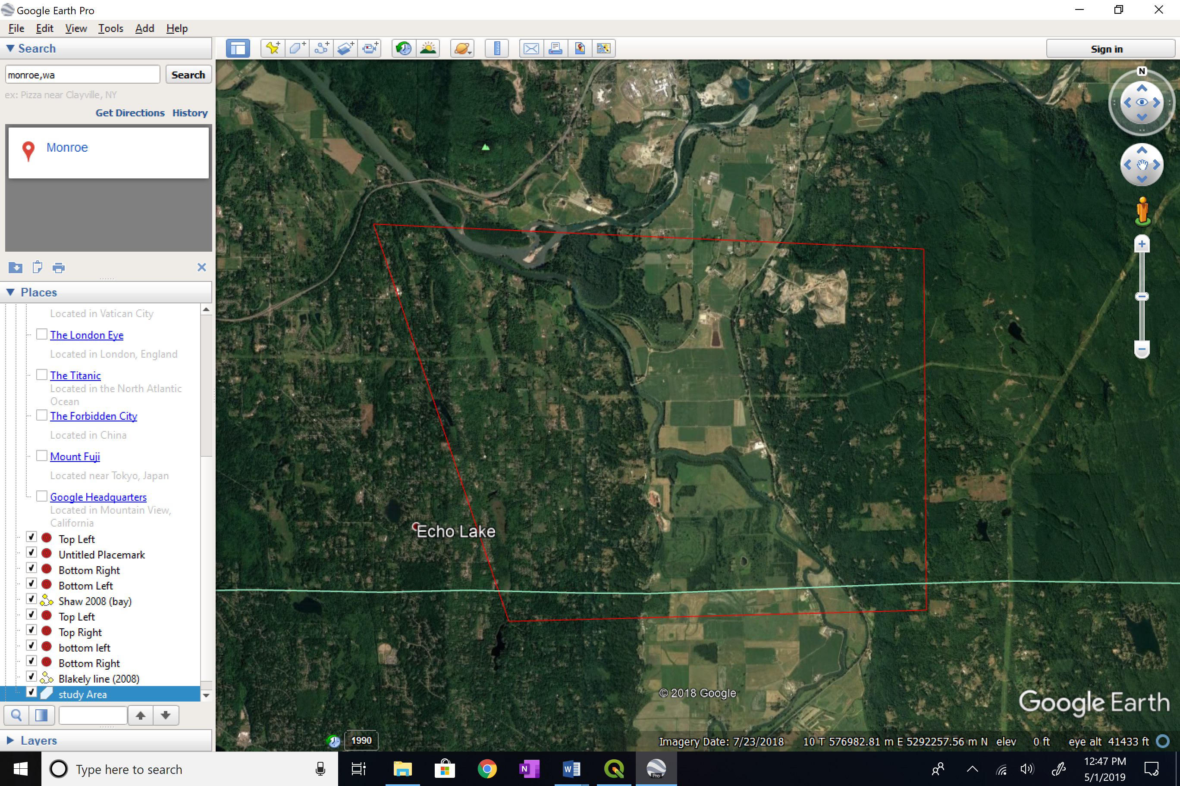

**Step 8: Define the crop field to be studied**

Within our study area, we will identify one crop to monitor during the growing season of May to October. The crop we will analyze is “corn” which is used for cattle feed.

Define the corners of our crop field study area by longitude and latitude coordinates. For this study, the boundaries are provided for you using coordinates determined by GPS. For your own projects, you will need to set your own boundaries for your study area.

We will create a vector layer in QGIS using the corners of our study area which are:

Lon,Lat

-121.9996,47.8078

-121.9957,47.8079

-121.9940,47.8085

-121.9849,47.8084

-121.9842,47.8059

-121.9935,47.8058

-121.9937,47.8051

-122.0000,47.8050

For Windows: Copy and paste the lines above into a text (.txt) file using Notepad

For Mac: Copy and paste the lines above into Pages and export as Plain Text (.txt)

Name the file *CropCornerPoints* and save the file in the folder *Monroe.*

On the **QGIS** menu bar

Select **Layer**

Select **Add Layer**

Select **Add Delimited Text Layer**

In **File Name** box

Browse to the folder *Monroe*

Select file *CropCornerPoints*

**Open**

In the **File Format** box

Select *CSV*

In the **Record and Fields Options** box

Select *0* in **Number of header lines to discard**

Select check markin box next to **First record has field names**

On the **Geometry Definition** line

Select *Point Coordinates*

In the **Geometry CRS** box

Select *ESPG:32610 WGS 84 / UTM zone 10N*

**Add**

**Close**

Now, follow the instructions in Steps 4-7 to create a crop area layer by connecting the corner points of the crop area layer. Be careful to substitute the name “Crop” for “Study”

Note: this area is 116 acres / 47 hectares

The crop area on our computer screen should look similar to this image:

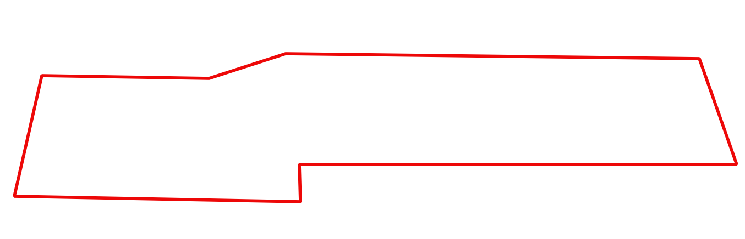

**Step 9: Save the project and exit**

On the **QGIS** menu bar

Select **Project** > **Save**

On the **QGIS** menu bar

Select **Project >** **Exit QGIS > Save**

Note: If you have access to Google Earth via internet, an alternate method of defining your study area and crop area can be used – see Chapter 18.

# Part 3: Adding Remote Sensed Data in GIS

## Chapter 6: Locating Remote Sensed Data

This chapter includes:

* Identifying sources of remote sensed images
* Understanding the data available in the Landsat archive

**Identifying sources of remote sensed images**

The Landsat archive is one of the largest and most accessible sources of remote sensed images. For our exercises, we will use Landsat images. However, after you become familiar with the process of using remote sensed images in GIS, you should research and bookmark other sources of images to provide a strong variety of tools for your future remote sensing and GIS needs.

The Landsat satellite imaging program was designed by scientists and sponsored by the US government to make large-scale, continuous surveys of the Earth's land areas. Today, the Landsat image library contains the longest continuous record of environmental conditions of land areas covering our world.

To date, eight Landsat satellites have been launched, beginning with Landsat 1 in 1972, up to Landsat 8 in 2013. Currently, both Landsat 7 and 8 are operational. Each satellite makes a complete orbit every 99 minutes, completes about 14 full orbits each day, and crosses every point on Earth once every 16 days. The satellites’ orbits are offset to allow 8-day repeat coverage of any Landsat scene area on the globe. Between the two satellites, more than 1,000 scenes are added to the USGS archive each day.

Although sensing equipment has been continuously improved, great effort has gone into keeping the format, resolution, and spectral sampling parameters consistent. This consistency allows for comparison of land area characteristics to analyze changes during the 40+ years of Landsat data collection.

For our purposes, one of the most attractive features of Landsat images is that the US government has made all 40+ years of data available on the internet for downloading at no cost to the public. We will make use of the Landsat image data in this textbook as one of our primary sources in learning about remote sensing.

This textbook is meant to give you only a very brief introduction to Landsat imagery; a complete discussion of the history and specifications of Landsat are beyond the scope of this textbook. For more information on Landsat, visit the USGS website at [www.usgs.gov](http://www.usgs.gov/). Another excellent source of Landsat information can be found in Chapter 6 of *Introduction to Remote Sensing, Fifth Edition*, by James B. Campbell and Randolph H. Wynne. Wikipedia also contains useful information about Landsat at <https://en.wikipedia.org/wiki/Landsat_program>.

**EarthExplorer**

The EarthExplorer website, operated by the US Geodetic Survey, is one of the most useful and complete sources of remote sensing data.

In order to download files using EarthExplorer, you must first create a login.

If you have not already set up an account, do so now.

Go to [http://earthexplorer.usgs.gov](http://earthexplorer.usgs.gov/)

On the bar near the top of the page, select **Register** and complete the form. You may need to ask an instructor to provide some answers. When you are done, a registration confirmation will be sent to your email address. Follow the link to activate your account.

Be sure to record your username and password for future use.

Return to EarthExplorer’s main page. If you are not already logged in, on the bar near the top of the page, select **Login** > **Sign in** with your username and password.

In the **Address/Place** box > type *Monroe, WA* > **Show**

Select **Monroe, WA, USA**

In the **Coordinates** box, select the **Decimal** tab.

Record the latitude and longitude, which will be used in the next step. Note that the longitude has a negative sign.

On the EarthExplorer menu bar, select **Logout**.

**GLOVIS (USGS Global Visualization Viewer)**

GLOVIS is another format for viewing Landsat images.

Go to [http://glovis.usgs.gov](http://glovis.usgs.gov/)

Click on the **Launch GLOVIS** button.

In the upper right corner of the screen, click on the button and select **Lat/Lng**.

Type the latitude and longitude from the previous step.

Click on the **Jump to Location** button

You can explore the many features of **GLOVIS** later.

**LandsatLook**

Another place to search for remote sensed image data is on the easy-to-use USGS website [http://landsatlook.usgs.gov](http://landsatlook.usgs.gov/) This site allows you to search for a location and then zoom in to see the full resolution data of all Landsat scenes available. When you select an image to download, the request will be processed by EarthExplorer.

**Esri’s Landsat Explorer** provides quick and easy access to more than 500,000 Landsat images. Normalized Difference Vegetation Index analysis are available for world-wide locations; however, the resolution is not detailed enough for use in the crop monitoring of our project.

<http://landsatexplorer.esri.com/>

## Chapter 7: Acquiring Remote Sensed Data

This chapter includes:

* Researching available data for your study area
* Downloading Landsat data
* Some useful facts about Landsat data

The EarthExplorer website, operated by the US Geodetic Survey, is one of the most useful and complete sources of remote sensing data. You will download Landsat images covering your study area. A good description of the Landsat program can be found at <http://en.wikipedia.org/wiki/Landsat_program>

Two versions of Landsat images are available.

Level 1 images are georeferenced for consistency but are not corrected for atmospheric conditions. Level 1 images are available very quickly after the image is captured by the Landsat sensors.

Level 2 images have atmospheric corrections applied to Level 1 data to produce surface reflectance measurements. Surface Reflectance products provide an estimate of the surface spectral reflectance as it would be measured at ground level in the absence of atmospheric scattering or absorption. Level 2 images are available within 1-3 days following the time the images are captured by the Landsat satellite sensors.

Why use Level 2 instead of Level 1? The primary reason is that Level 2 images have been atmospherically corrected so the consistency between images captured on different days is much higher.

The process of producing Level 2 images can best be researched online for those interested in the details but is beyond the scope of this curriculum.

For our study, from this point forward, we will use Landsat Level 2 images.

**Step 1: Create a folder for saving Landsat images**

In the *Monroe* folder, create a sub-folder named *Landsat*.

**Step 2: Log into the USGS website**

Go to <http://earthexplorer.usgs.gov/>

On the **EarthExplorer** menu bar, select **Login** > **Sign in** with your username and password. If you have not already set up an account, follow the instructions in the previous chapter.

**Step 3: Define the parameters for your request for Landsat images Level 2**

When choosing date ranges for images, think carefully about the vegetation condition of crops at various times of the year - planting, growing, harvest, fallow.

On 15 May 2018 the condition of the field being studied was freshly plowed and the corn seed was planted that day. This is the view seen from a drone of half of the field 2 days after planting. The green “fingers” are drainage ditches.

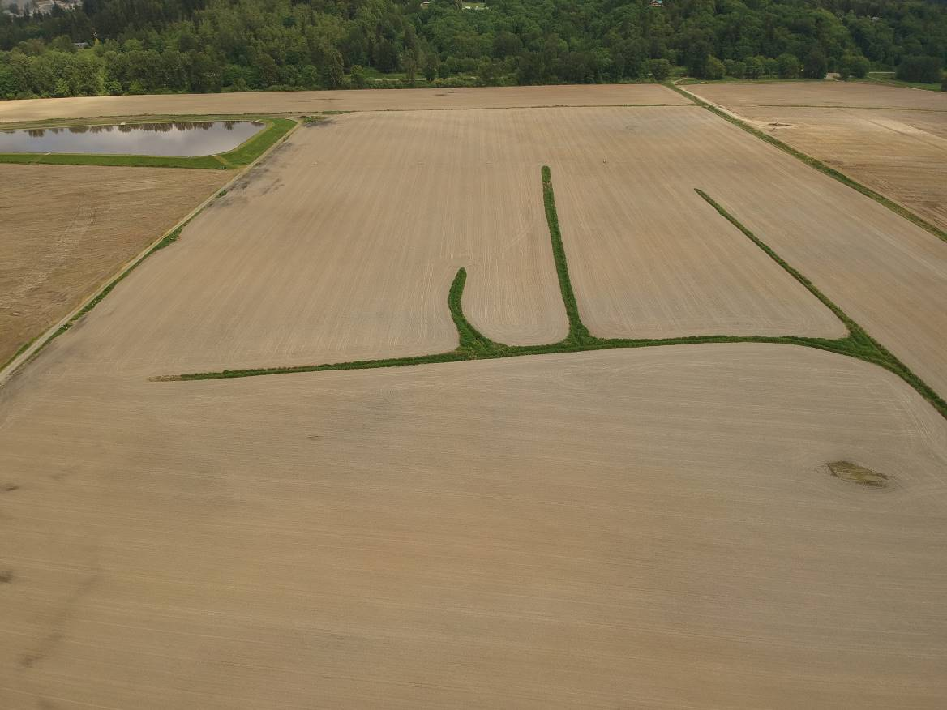

Now look for the Landsat image nearest the date of planting.

In the box **Address/Place** > type *Monroe, WA* > **Show**

Select **Monroe, WA, USA** from the list displayed in the **Address/Place** box.

Select a **Date Range**

For this exercise choose the date range of *05/13/2018* to *05/15/2018*

Select the **Data Sets** tab

Click the + box next to **Landsat**

Click the + box next to **Landsat Collection 1 Level 2 (on demand)**

Click the box next to **Landsat 8 OLI/TIRS C1 Level-2**

Select the **Results** button at the bottom of the pane

For the image for *Path 46 Row 27*

Select **Order Scene** icon 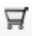 for the map you chose

Select the **View Item Basket** button

Select the **Proceed to Checkout** button

Click the title of the **Data Set** in the item basket

Select the **Submit Order** button

Select **Logout**

In your email folder you should receive the following emails:

* Order confirmation
* Processing the order
* Processed order available for download (might take some time to receive)

After the third email arrives (“available for download”)

Note the last four digits of the order number

Double click on the link to begin the download

Select the file with correct order number to download (usually the topmost)

Click on **Download**

After the download completes, browse to locate the downloaded file

**Copy / paste** the file to the folder *Landsat* in the folder *Monroe*

**Step 4: Uncompress the Landsat Level 2 file**

For Mac using Keka (Mac version of 7-Zip), skip this step. Setting Keka as the default extraction application in Chapter 3, Step 3 will allow Keka to automatically uncompress or extract the downloaded Landsat file.

Uncompress the downloaded Landsat file (7-Zip is a commonly used program for this purpose)

Browse to the folder *Landsat*

Uncompress Landsat images in *gz* file using **7-Zip** (or whatever program you use to uncompress files)

Uncompress Landsat images in *tar* file using **7-Zip** (or whatever program you use to uncompress files)

Select folder **Landsat** as the destination for the unzipped files

**Step 5: Organize files**

**Browse** to the folder *Landsat*

Create folders with these names:

14-May-2018

15-Jun-2018

8-Jul-2018

24-Jul-2018

3-Sep-2018

19-Sep-2018

12-Oct-2018

Copy the downloaded Landsat files ending in *sr-band4* and *sr-band5* into the folder named *14-May-2018*

**Step 6: Cleanup files**

When you are finished, you can delete the *gz* and *tar* files to save disc space

# Part 4: Analyzing Remote Sensed Data

## Chapter 8: Image Interpretation

This chapter includes:

* Interpreting single images
* Interpreting analyzed images

**Interpreting single images**

Photos and satellite images are useful primarily because they can be used to identify the position and properties of features that are of interest. Interpreters use size, shape, color, brightness, texture and location to identify features and convert images into information. Image interpreters must have some familiarity with the features of interest. Ground truthing is essential to develop the local knowledge required for accurate image interpretation.

The practice of image interpretation is a well-developed discipline and uses many specialized techniques. A detailed description of image interpretation is beyond the scope of this handbook. Books and internet resources are available that teach this skill in detail.

Satellite images are like maps: they are full of useful and interesting information, provided you have a key. It is important to remember that satellite images are an overhead view -- an unfamiliar perspective. The following is a review of a few of the highlights of image interpretation focusing on satellite images.

**Look for a Scale:** One of the first things people want to do when they look at a satellite image is to identify the places that are familiar to them: their home, school, or place of business; a favorite park or tourist attraction; or a natural feature like a lake, river, or mountain ridge. The level of detail depends on the image’s spatial resolution. Like digital photographs, satellite images are made up of little dots called pixels. The width of each pixel is the satellite’s spatial resolution. For the Landsat images we will be using, the resolution for one pixel is 30 meters on each side (900 sq meters).

**Look for patterns, shapes, and textures:** Bodies of water—rivers, lakes, and oceans—are often the simplest features to identify because they tend to have unique shapes and they show up on maps. Other obvious patterns come from the way people use the land. Farms usually have geometric shapes—circles or rectangles—that stand out against the more random patterns seen in nature. When people cut down a forest, the clearing is often square or has a series of herring-bone lines that form along roads. A straight line anywhere in an image is almost certainly human-made, and may be a road, a canal, or some type of boundary made visible by land use.

**Define Colors:** The colors in an image will depend on what kind of light the satellite instrument measured. True-color images use visible light—red, green and blue wavelengths—so the colors are similar to what a person would see from space. False-color images incorporate infrared light and may take on unexpected colors.

**Water:** Water absorbs light, so it is usually black or dark blue.

**Plants:** Plants come in different shades of green, grasslands tend to be pale green, while forests are very dark green. Land used for agriculture is often much brighter in tone than natural vegetation. In some locations (high and mid latitudes), plant color depends on the season. Spring vegetation tends to be paler than dense summer vegetation. Fall vegetation can be red, orange, yellow, and tan; leafless and withered winter vegetation is brown. For these reasons, it is helpful to know when the image was collected.

**Find North:** If you know where north is, you can figure out if that mountain range is running north to south or east to west, or if a city is on the east side of the river or the west. These details can help you match the features to a map

**Consider your Prior Knowledge:** Perhaps the most powerful tool for interpreting an image is knowledge of the place. If you know that a wildfire burned through a forest last year, it’s easy to figure out that the dark brown patch of forest is probably a burn scar, not a volcanic flow or shadow.

**Interpreting analyzed images**

Because most of us are not trained and experienced interpreters of remote sensed images, we will use some techniques of automated image analysis to help us understand the image data we are seeing. One specialized analysis technique we will learn in the next chapter is Normalized Difference Vegetation Index (NDVI). Instead of attempting to interpret individual images, we will use QGIS software to analyze two images and produce a visualization that is customized for the interpretation of vegetation health.

Using established processes such as NDVI transfers our interpretation requirements from examining raw remote sensed image data to understanding and interpreting automated analysis methods and outputs. More on this topic in the next chapter.

## Chapter 9: Normalized Difference Vegetation Index (NDVI)

This chapter includes:

* Definition of NDVI
* Instructions for completing NDVI analysis
* Examples of NDVI outputs

The **Normalized Difference Vegetation Index (NDVI)** has been used for many years to measure and monitor plant growth (vigor), vegetation cover, and biomass production from multispectral satellite data. We will create NDVI image maps using Landsat data in the visible red and near infrared regions of the electromagnetic spectrum.

**NOTE: –** For images fromLandsat satellites 1-7; band 3 is used for red and band 4 for near-infrared. For Landsat 8 the band designations changed; red is now band 4 and near-infrared is now band 5.

NDVI for Landsat 8 is calculated as follows:

***NDVI = (*Band 5 *–* Band 4*) / (*Band 5 *+* Band 4*)***

The principle behind NDVI is that Band 4 is in the visible red-light region of the electromagnetic spectrum where chlorophyll causes considerable absorption of incoming sunlight. Band 5 is in the near-infrared region of the spectrum where a plant's spongy mesophyll leaf structure creates considerable reflectance. As a result, vigorously growing healthy vegetation has low red-light reflectance and high near-infrared reflectance, and hence, high NDVI values.

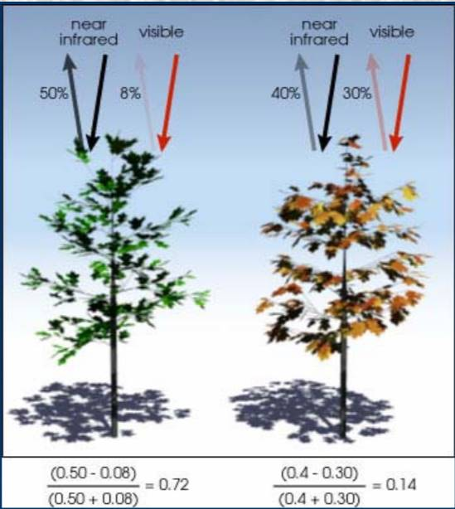

This relatively simply algorithm produces output values in the range of -1.0 to 1.0.

* Negative values of NDVI (values approaching -1) correspond to deep water.
* Values near zero (-0.1 to 0.1) generally indicate non-vegetated features such as barren surfaces (rock and soil) and water, snow, ice, and clouds.
* Low, positive values represent shrub and grassland (approximately 0.2 to 0.4).
* High values indicate temperate and tropical rainforests (values approaching 1).
* Typical range of values is between about 0.2 (for a not very green area) to 0.9 (for a very green area)

**Step 1: Define our study area**

In Chapter 5 we defined our study area and created a shapefile named *StudyArea* that we will use in this exercise. If you have not already created the study area map, follow the instructions in Chapter 5 now.

**Step 2: Add Landsat images to the QGIS project**

At the time these instructions were prepared, the current version of QGIS is 3.4. When later versions are released, some changes to these instructions may be needed.

Start **QGIS**

On the **QGIS** menu bar

Select **Project** > **Open**

Browse to folder *Monroe*

Select **File Name** *CropMonitoring*

**Open**

Next, load the Landsat images downloaded in Chapter 7 into QGIS and clip the data images to only include data for the study area. Only images from spectral bands red and near infrared (NIR) will be used to calculate NDVI.

The following instructions assume the use of images from Landsat 8. If using images from Landsat 1-7, change the band numbers to 3 and 4.

On the **QGIS** side bar select the **Add Raster Layer** icon 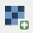

Browse to the folder *14-May-2018* in folder *Landsat*

Select the file ending in *sr-band4* (band 4)

Select the file ending in *sr-band5* (band 5)

**Open** **> Add**

**Close**

**Step 3: Clip Landsat images to the size of the study area**

Clip the Landsat images to the size of the study area. Note: it is important to perform these steps in the following order.

On the **QGIS** menu bar

Select **Raster** > **Extraction** > **Clip Raster by Mask Layer**

In the **Input layer** box, select the file ending in *sr-band4* (band 4)

In the **Mask layer** box, select *StudyArea*

Check box **Match the extent of the clipped raster to the extent of the mask layer**

Click on **Run** button

**Close**

In the **Layers** panel

Right click on layer *Clipped (mask)*

Select **Rename Layer**

Type*band4* in the layer name

**Enter**

Repeat the previous actions in this step for the layer ending in *sr-band5* (band5)"

Right click the first Landsat image layer with the long name ending in*..sr_band4*

**Remove Layer > OK**

Right click the second Landsat image layer with the long name ending in *.sr_band5*

**Remove Layer > OK**

Right click on the layer *StudyArea*

Select **Zoom to Layer**

On the **QGIS** menu bar

Select **Project** > **Save**

Landsat data for the study area displayed on your computer screen should now look similar to this: (see below)

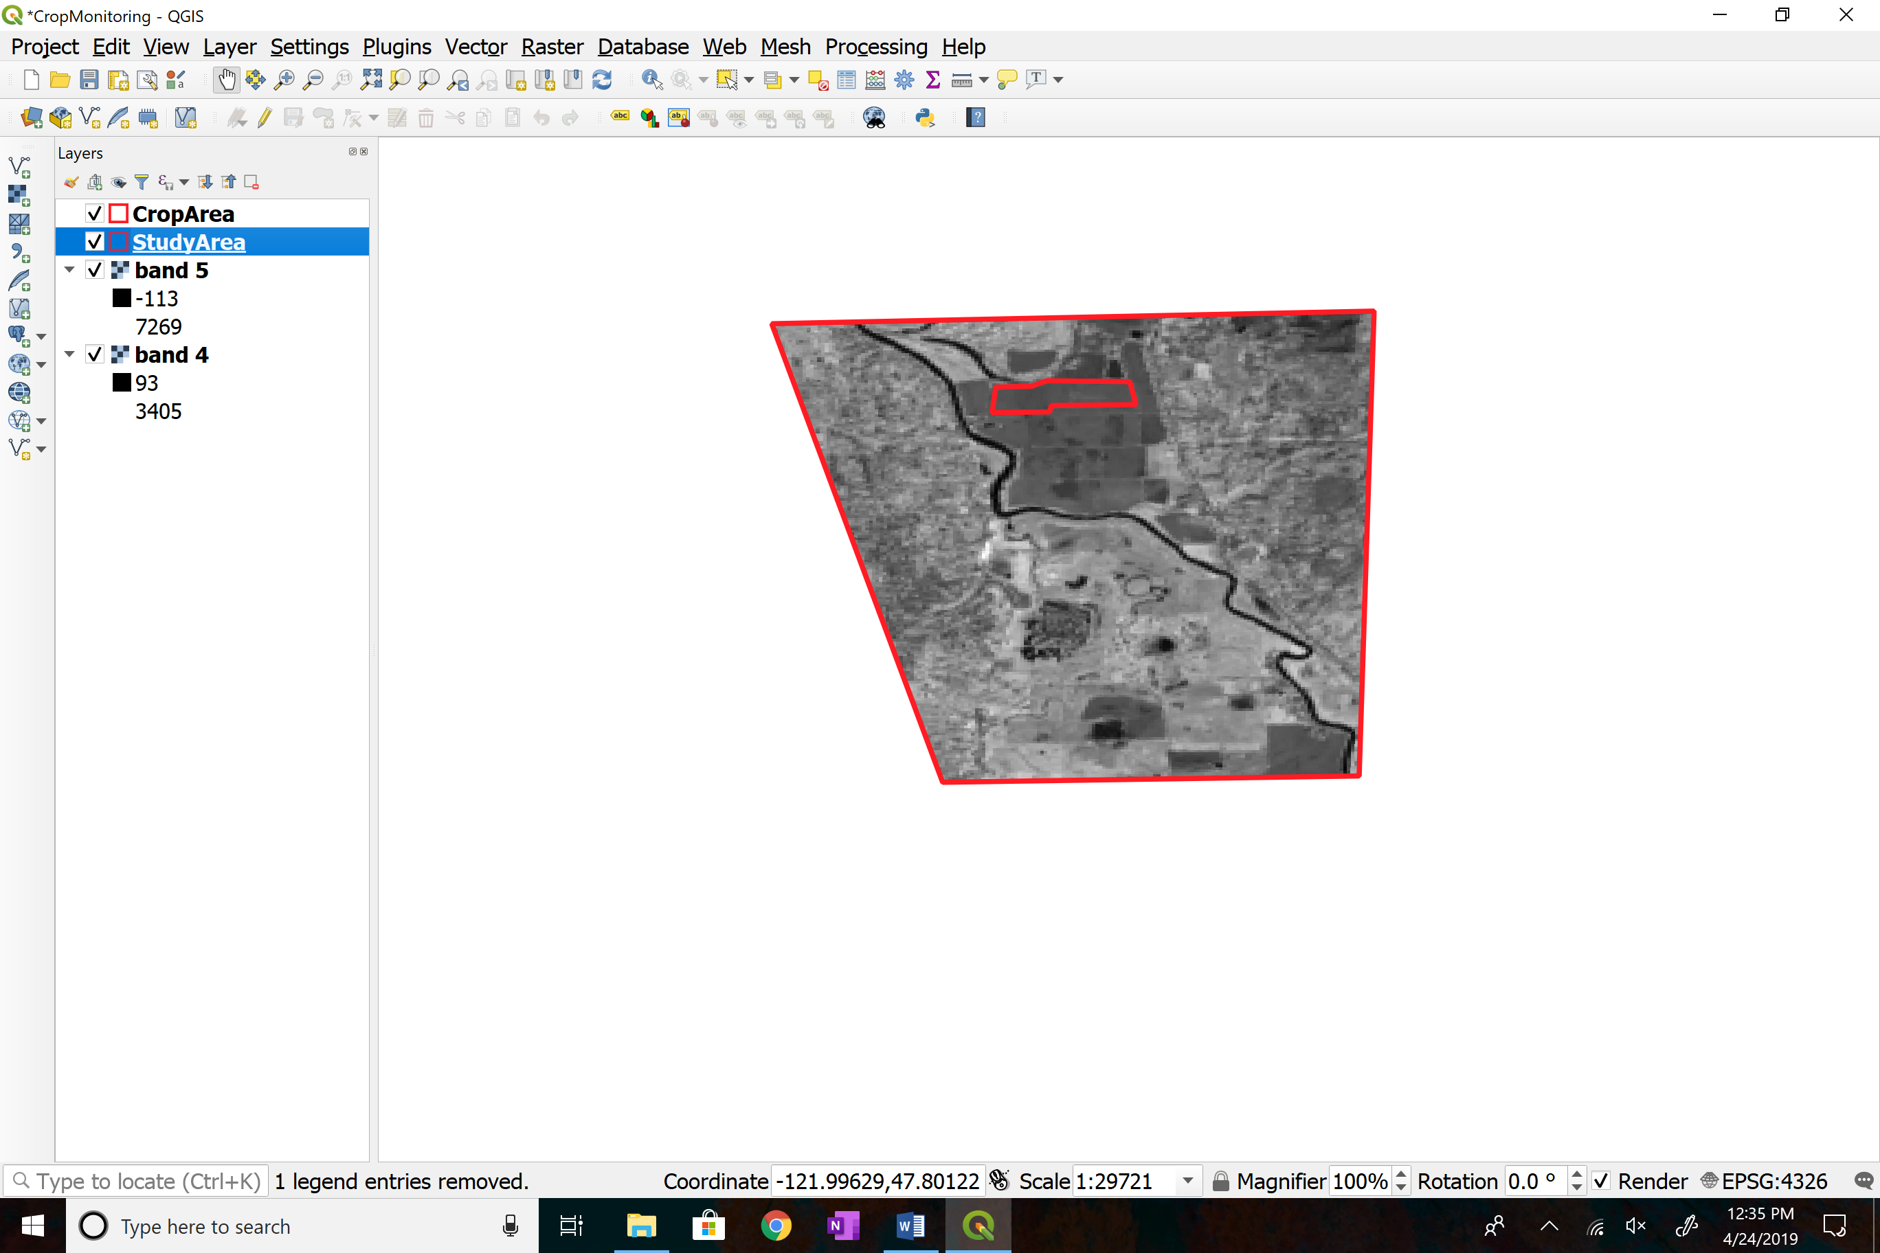

**Step 4: Perform calculations to create the NDVI raster layer**

Each Landsat image is a single band grayscale raster with integer pixel values (1-65536). Since NDVI is “normalized” the values are always fractions. Therefore, it is necessary to first multiply the raster *band5* by 1.0 to convert it to a real value. Otherwise the result will be an integer, leaving the whole computed NDVI raster with values rounded to 0.

On the **QGIS** menu bar

Select **Raster > Raster calculator**

Click on the box to the right of **Output layer** box

Browse to the folder *14-May-2018* in folder *Landsat*

Type *NDVI-14-May-2018* in **File Name** box

**Save**

In the **Output CRS** box

Select *ESPG:32610 WGS 84 / UTM zone 10N*

Enter the following expression in the **Raster calculator expression** box

(Enter this formula by double-clicking on each item and operator on the screen. The number “1.0” must be typed in). do not copy paste (it won't work)

("band5@1" * 1.0 - "band4@1") / ("band5@1" + "band4@1")

**OK**

**Step 5: Create an NDVI color ramp**

(it is only necessary to perform this step one time)

GIS software uses a “color ramp” to assign various colors to represent a range of reflectance values. One example of a color ramp looks like this:

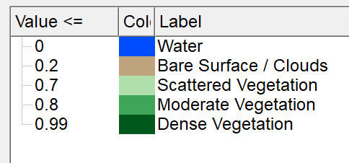

Define a color ramp in QGIS by performing a **one-time action** to create a custom NDVI color ramp. This step creates a custom color ramp file that will be used in the following steps.

**Select** and **Copy** the following text

# QGIS Generated Color Map Export File – Landsat Level-2

INTERPOLATION:DISCRETE

0.0,0,76,255,255,Water

0.2,191,163,124,255,Bare Surface / Clouds

0.7,177,223,171,255,Scattered Vegetation

0.8,61,166,89,255,Moderate Vegetation

0.99,0,87,27,255,Dense Vegetation

Start **Word** (or compatible program such as Notepad)

**File > New** to create a blank document

**Paste** the copied text into the blank document

**File > Save As**

Browse to the folder *Landsat*

Name the file *NDVIColorRamp-Level2*

Select **Save as type** *Plain Text*

**Save > OK**

**File > Close**

In QGIS uncheck all the layers except the layer named *NDVI-14-May-2018*

Right click on *NDVI-14-May-2018*

**Properties** > **Symbology**

In **Render type** select *Singleband psuedocolor*

In **Interpolation** select *Discrete*

Click on the file folder icon 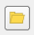

Browse to folder *Landsat*

Select *NDVIColorRamp-Level2*

**Open**

The color ramp should now look similar to this:



Click on down arrow to the right of the box labelled **Style at the bottom-left of the page**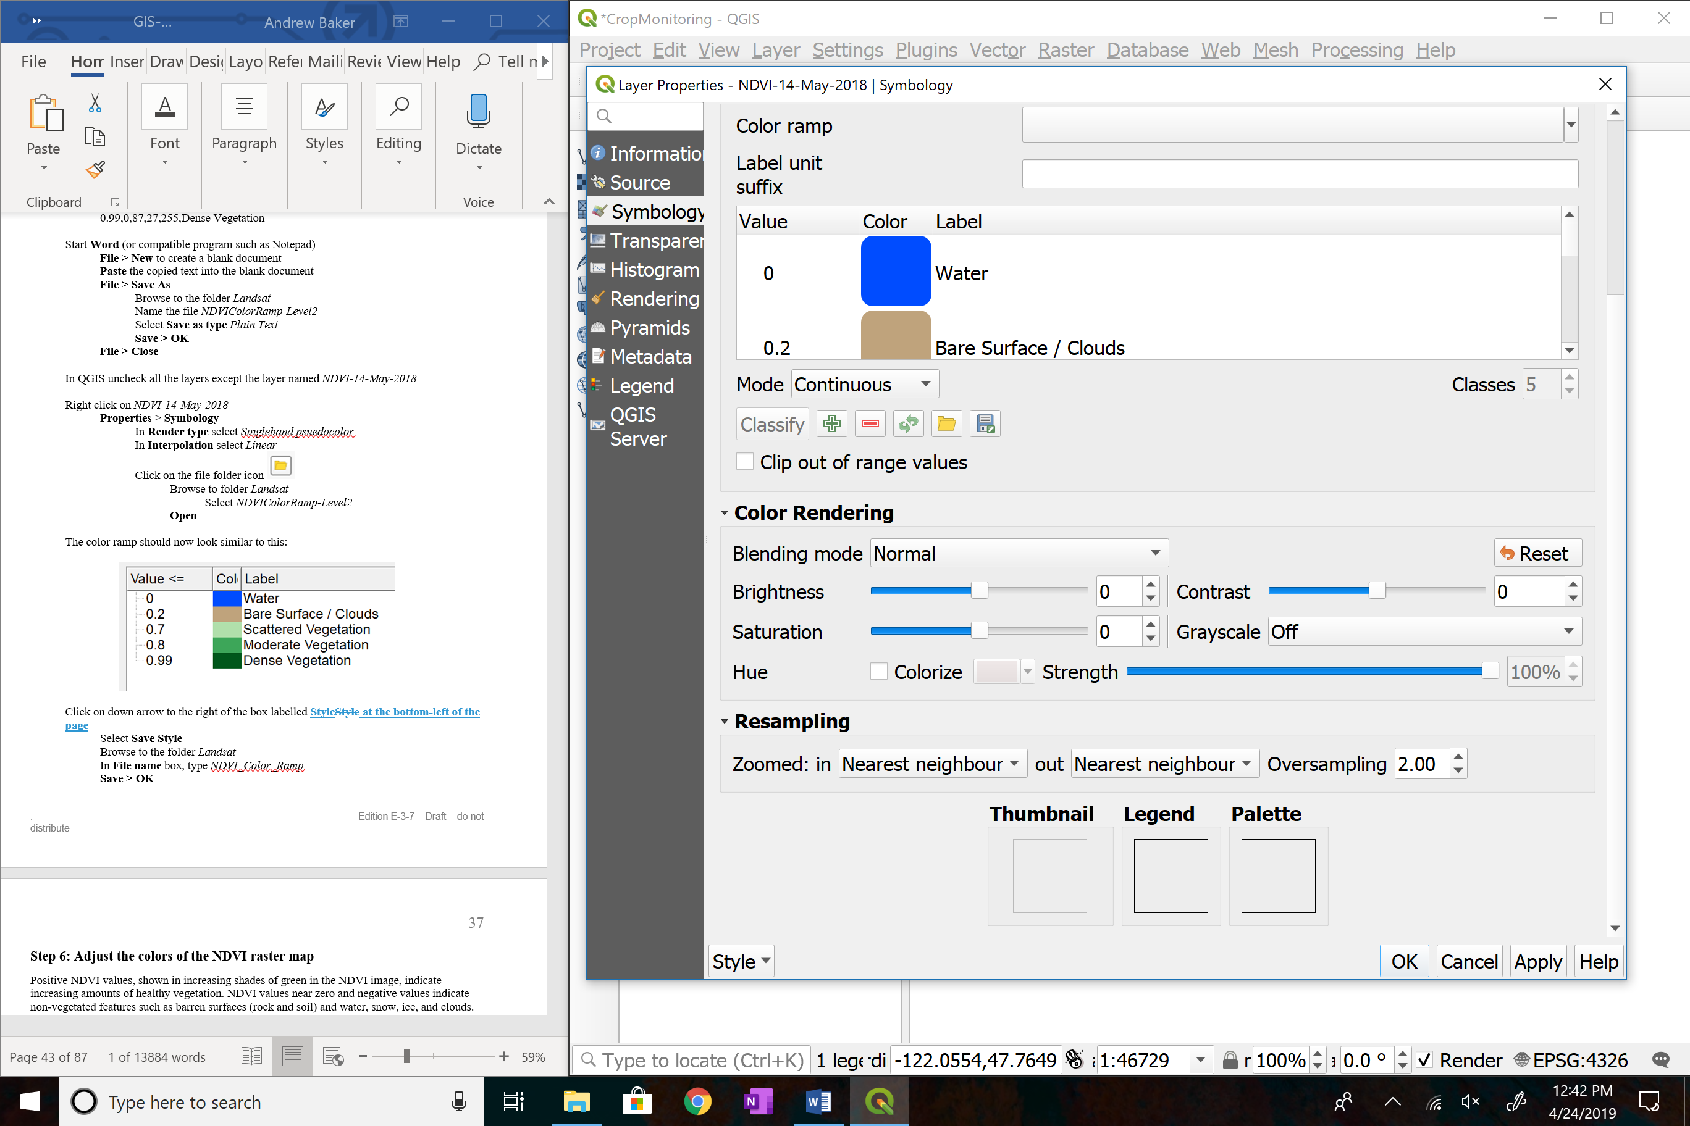

Select **Save Style**

Browse to the folder *Landsat*

In **File name** box, type *NDVI_Color_Ramp*

**Save > OK**

**Step 6: Adjust the colors of the NDVI raster map**

Positive NDVI values, shown in increasing shades of green in the NDVI image, indicate increasing amounts of healthy vegetation. NDVI values near zero and negative values indicate non-vegetated features such as barren surfaces (rock and soil) and water, snow, ice, and clouds.

Right click on the layer named *NDVI-14-May-2018*

**Properties** > **Symbology**

Click on down arrow to the right of the box labelled **Style**

Select **Load Style**

Browse to the folder *Landsat*

Select the file named *NDVI_Color_Ramp*

**Open**

The color ramp should look similar to this:



When a pixel value falls between two numbers, the color of the higher number in the range will be rendered.

Select **OK**

At this point your screen should look something like this:

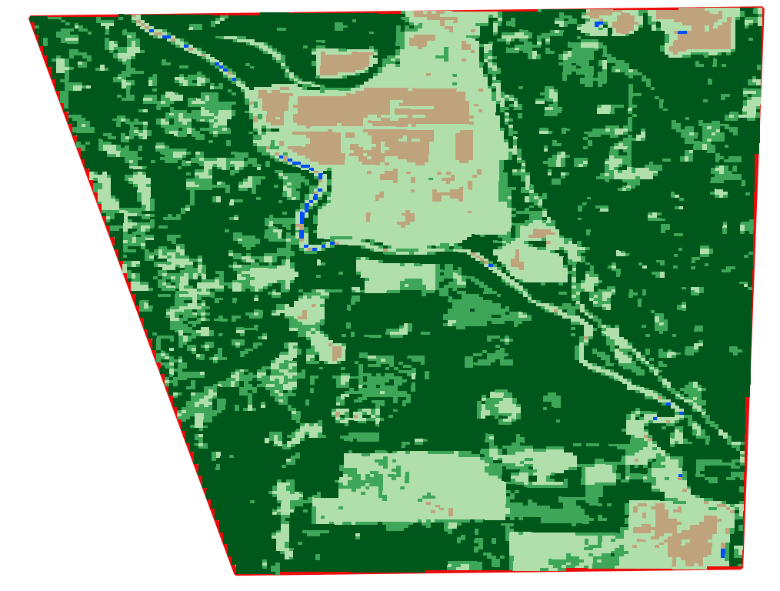

NDVI Level-2 analysis of study area for 14 May 2018

**Step 7: Making changes to the color ramp**

For this case study, the color ramp does not need any change. However, if a change is necessary based on ground truthing data, changes can be made by following this method:

Select layer *NDVI-14-May-2018* > **Properties** **> Symbology**

To change a **Value, Color** or **Label**

Double click on the item to be changed

Type a different value

Press **Tab** key

**OK**

**Step 8: Update metadata for the NDVI layer**

Select layer *NDVI-14-May-2018* > **Properties** > **Metadata**

In the **Title** box of the **Identification** tab, copy and paste the following text

NDVI Level 2 – 14 May 2018

In the **Abstract** box, copy and paste the following text

Data source: USGS, Landsat 8, Path 46 / Row 27

Acquisition Date: 14-May-2018

In the **Access** tab, in the **Rights (attribution or copyright)** box

Click on + button

Copy and paste the following text

*Landsat images courtesy of the U.S. Geological Survey*

**Apply > OK**

**Step 9: Cleanup**

Right click the layer named *band4*

**Remove > OK**

Right click the layer named *band5*

**Remove > OK**

**Step 10: Save the project and exit**

On the **QGIS** menu bar

Select **Project** > **Save**

On the **QGIS** menu bar

Select **Project >** **Exit QGIS > Save**

**Step 11: Interpretation**

Recall from the definition of NDVI that the intense green is the most complete coverage of healthy vegetation. At the opposite extreme in the example using the custom color ramp is blue indicating water surfaces. Large areas of brown indicate non-vegetative surfaces which, at this time of the year, is likely bare earth or a mix of bare earth with sparse vegetation such as weedy areas.

**Exercise:** The resolution of Landsat images is 30 by 30 meters. This means that when calculating the NDVI values, each pixel value represents an area of 900 square meters. To get an idea of the size of the area represented in one pixel of the Landsat image, go outside and do the following:

* Locate an open area
* Mark a starting point with an object large enough to be seen from a distance
* Walk away from the object while counting your steps
* Count until you reach 35 normal steps
* Look back to your starting point
* Imagine that the line between your current location and the starting point is one side of a square
* Envision the size of the square which is the area represented by one pixel of a Landsat image

## Chapter 10: Applying NDVI Analysis

***To Crop Field Area***

This chapter includes:

* Clip NDVI analysis area to selected crop field
* Interpretation of completed NDVI analysis

In Chapter 5 a corn field was chosen to follow for the study of crop development. Clip the study area NDVI image to only contain values inside the crop area.

Note: the term “crop” has two different meanings in the following text.

* Crop (noun) a cultivated plant that is grown as food, e.g., a grain, fruit, or vegetable
* Crop (verb) to cut very short, trim, snip

**Step 1: Open the QGIS project file**

Start **QGIS**

On the **QGIS** menu bar

Select **Project** > **Open**

Browse to folder *Monroe*

Select **File Name** = *CropMonitoring*

**Open**

**Step 2: Clip NDVI image to the size of crop field area**

On the **QGIS** menu bar

Select **Raster** > **Extraction** > **Clip raster by mask layer**

In the **Input layer** box

Select the layer *NDVI-14-May-2018*

In the **Mask layer** box

Select the layer *CropArea*

Check the box

**Match the extent of the clipped raster to the extent of the mask layer**

In the **Clipped** **(mask)** box, select **Save to File**

Browse to folder *14-May-2018* in folder *Landsat*

In **File** **Name** box type *NDVI-Crop-14-May-2018*

**Save**

Click on **Run** button

**Close**

In the **Layers** panel

Right click on layer *Clipped (mask)*

Select **Rename Layer**

Type*NDVI-Crop-14-May-2018* in the layer name

**Enter**

Uncheck the box next to the layer *NDVI-14-May-2018*

Check the box next to the layer *CropArea*

Right click on the layer *CropArea*

Select **Zoom to Layer**

(optional) Right click on the layer *NDVI-14-May-2018*

Select **Remove Layer > OK**

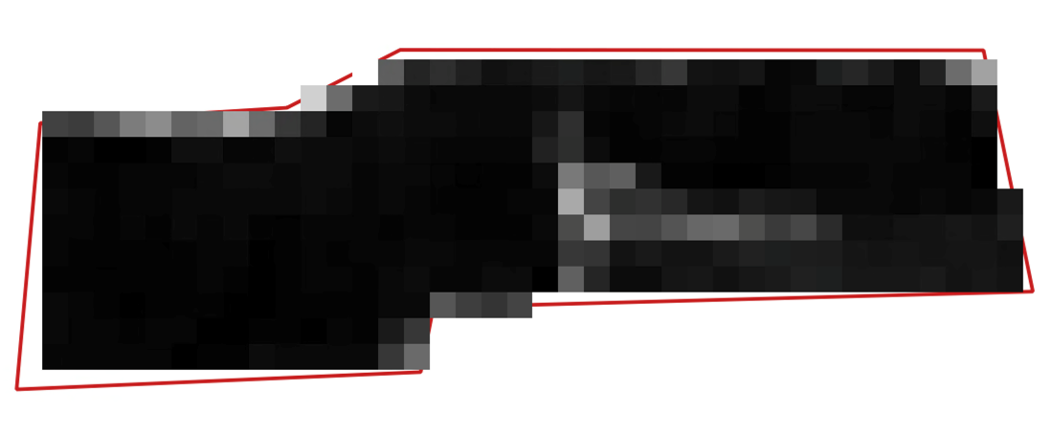

**Step 3: Adjust the colors of the NDVI raster map**

Positive NDVI values, shown in increasing shades of green in the NDVI image, indicate increasing amounts of healthy vegetation. NDVI values near zero and negative values indicate non-vegetated features such as barren surfaces (rock and soil) and water, snow, ice, and clouds.

Select layer *NDVI-Crop-14-May -2018*

**Properties** > **Symbology**

In **Render type** select *Singleband pseudocolor*

In **Interpolation** select *Linear*

Scroll down

Click on the file folder icon 

Browse to folder *Landsat*

Select *NDVIColorRamp-Level2*

**Open**

**OK**

At this point the screen should look similar to the following image. Instructions for adding a legend, scale bar and comments are covered later in Chapter 16.

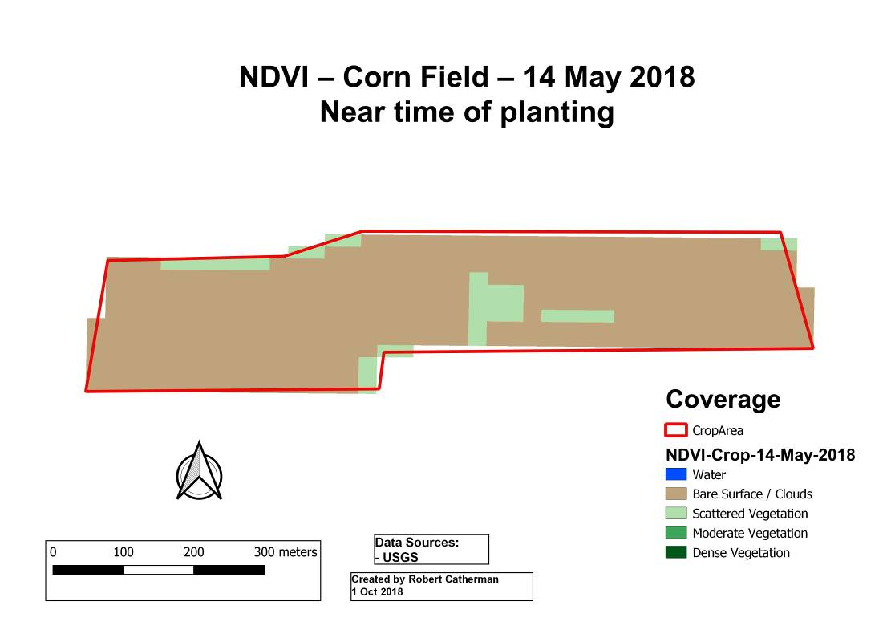

NDVI Level-2 analysis for 14 May 2018

**Step 4: Interpretation**

From the NDVI analysis we draw the conclusion, that, on 14 May 2018, most of the field is bare dirt (brown) but some scattered vegetation (light green) is growing in the drainage ditches and at the edges of the plowed field.

In QGIS

Select the layer *NDVI-Crop-14-May-2018*

Click on the “information icon” 

In the lower left corner of the **Identify** **Feature** panel

In the **View** box, choose *Tree*

Move the cursor over some light green cells, left click, and read values in the range of 0.3 to 0.4. Examine values in some brown cells.

## Chapter 11: Ground Truth Sampling

This chapter includes:

* Definition of ground truthing
* Using GPS in ground truthing data collection
* Sources of useful information for ground truthing

Ground truthing is a term used in remote sensing to refer to information collected on location. Ground truth information allows digital image data to be related to real features and materials on the ground.

Ground truthing is usually done on site, performing observations and measurements of various properties of the features of the ground resolution cells that are being studied on the remotely sensed digital image.

**Field note-taking:** Take detailed field notes of observations when you are on-site. You think you will remember the details – but a few weeks or months later, some details will be forgotten or remembered inaccurately.

**Local knowledge:** Talking with a local person may uncover useful information that is not obvious to your observations. Make a list of questions you need answered the next time you encounter a person who is familiar with your study area.

**GPS:** When using a GPS to determine the coordinates of a location, set the GPS datum to the same datum used by the digital maps in your GIS. One of the most commonly used datums is WGS 84. You can determine the datum used in your digital map by using your GIS software to look in the map’s metadata.

Set the GPS’s coordinate unit format to meet the input requirements of your GIS software, e.g., QGIS input requires that latitude and longitude be formatted as a decimal number so you must set the GPS coordinate unit’s format to degrees and decimals of degrees.

**Photos:** Photography is a valuable method of preserving your observations of time, place and conditions. Photos taken with a mobile device usually contain embedded latitude and longitude data if locations services are turned on (geotagging). An app such as ExifViewer downloaded to your mobile device will display metadata for each photo including lat / lon. Photos can be displayed on GIS maps if geotagging is enabled in the camera.

**Drones:** Photos taken from a drone allow you to “visit” locations in your study area that may not be accessible on foot. Although technically, drone photos are classified as another form of remote sensing, viewing your study area from a few hundred feet up can be almost like “being there”.

**Internet research:** Some ground truthing information can be found on property parcel map websites usually maintained in the US at the county level. The reason for maintaining parcel information at this level is because parcels are the basis for property taxation.

The following information on our corn field is from <http://gis.snoco.org/maps/property/index.htm> You can see that our corn field covers three parcels, the parcel with the red dot as well as the parcels to its left and right.

Parcel Number: 27062300400500

Parcel Owner: TULALIP TRIBES OF WA, 8802 27TH AVE NE, TULALIP, WA 98271

Size: 39.89 acres

Use code: 830 Open Space Agriculture RCW 84.34

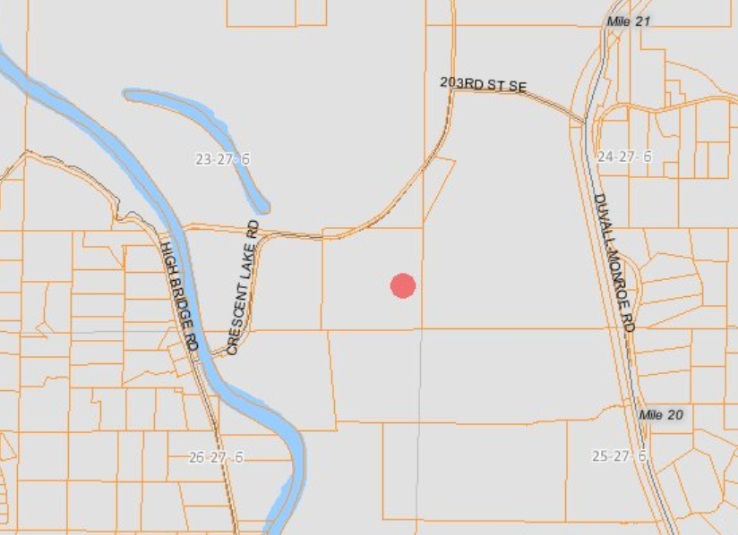

**Developing a Color Ramp for NDVI**

One important use of ground truthing data is for defining the values for the NDVI color ramp. You want to have confidence the colors displayed in your map legend accurately represents the reality of conditions in the study area.

General ranges of values in NDVI layers start with water at 0.0 (low end) and go to 1.0 (high end) for extremely healthy dense vegetation.

For this case study, define five categories of ground cover:

|  |  |  |  |
| --- | --- | --- | --- |
| **Category** | **Upper limit pixel value** | **Color** | **Color sample** |
| Water | 0.0 | Blue | …… |
| Bare Surface / clouds | 0.2 | Brown | …… |
| Scattered vegetation | 0.7 | Lt Green | …… |
| Moderate vegetation | 0.8 | Med Green | …… |
| Dense vegetation | 0.99 | Dark Green | …… |

Start the definition process at the lower end of NDVI values – those are the NDVI values of radiance from deep water. Locate a body of deep water on your map and note the coordinates. At that location on your NDVI layer, use the **Identify Features** icon to “read” the pixel values at several locations well inside the boundaries of the body of water. The highest value you observe will be the value defined as the upper limit for “water’. Normally, this upper limit for deep water is near zero.

Note: Shallow water such as puddles will have slightly positive values generally below 0.2. The same phenomenon is seen around the shoreline of deep-water bodies.

Next, move attention to the highest NDVI values – dense, healthy vegetation. It is best to visit some locations that have a dense canopy of tree cover. The size of the area should be at least 200 meters by 200 meters. As close as possible, use a GPS device to identify the coordinates of the center of the dense area. If an on-the-ground visit is not possible, an alternate method is to use Google Earth to determine coordinates of the center of an area of dense, healthy vegetation. Again, note the coordinates. At that location on your NDVI layer, use the **Identify Features** icon to “read” the pixel values at several locations well inside the boundaries of the dense vegetation. The lowest value you observe will be the value defined as the lower limit for “dense vegetation”.

Then, locate an area of bare surface or pavement. Get some help from Google Earth if necessary.

On the **QGIS** menu bar

Select **View > Panels > Browser**

Click on plus sign next to **XYZ Tiles**

Double click on **Google Satellite**

If **Google Satellite** is not shown

On the **QGIS** menu bar

Select **View > Panels >** check mark **Browser**

Right click on tab next to **XYZ Tiles** > **New Connection**

Type in **Name** box *Google Satellite*

Copy & Paste into **URL** box [*https://mt1.google.com/vt/lyrs=y&x={x}&y={y}&z={z}*](https://mt1.google.com/vt/lyrs=y&x=%7bx%7d&y=%7by%7d&z=%7bz%7d)

**OK**

Under **XYZ Tiles** double click on **Google Satellite**

Choose a 200x200 meter area and identify the coordinates of the center of the area. At that location on your NDVI layer, use the **Identify Features** icon to “read” the pixel values at several locations well inside the boundaries of the bare surface / pavement. The highest value observed will be the value defined as the upper limit for “bare surface / pavement”.

The values between “bare surface” and “dense vegetation” are not as easy to define. We will define two categories, “scattered vegetation” and “moderate vegetation”. Scattered vegetation for our purposes will represent the case where up to 50 % of the surface is covered by vegetation.

One method of defining color ramp values for scattered vegetation is to wait for the crop under observation to be planted and then choose a time when the vegetation covers no more than 50% of the ground and the other 50% is bare soil. Use the technique described earlier to identify the location and sample the pixel values in the NDVI image to set the “scattered vegetation” value in the color ramp.

Moderate vegetation for our purposes will represent the case where 50 to 80 % of the surface is covered by vegetation. When coverage is about 75% vegetation, repeat the steps for “moderate vegetation”. This range will also include the situation where vegetation is not healthy.

These color ramp value definitions are only approximations. Adjust the color ramp values to agree with the conditions observed during ground truthing.

## Chapter 12: Analyzing Images during the Growing Season

This chapter includes:

* Compute NDVI for a time series of different crop maturity stages
* Interpret the results of the analysis

We can analyze the change of vegetation as the corn crop matures.

**Step 1: Calculate NDVI for the yellow highlighted dates using Level 2 images**

|  |  |  |  |  |
| --- | --- | --- | --- | --- |
| **Activity** | **Date** | **Height (in)** | **Path** | **Row** |
| Too wet to plow | 4/19/2018 | 0 | 47 | 27 |
| Pre-till | 5/5/2018 | 0 | 47 | 26 |
| *Planted* | 5/14/2018 | 0 | 46 | 27 |
| Sprouted | 5/22/2018 | 2 | 47 | 27 |
| *Part veg/part dirt* | 5/30/2018 | 5 | 46 | 27 |
| Part veg/part dirt | 6/6/2018 | 8 | 47 | 27 |
| 50% coverage – sct clouds | 6/15/2018 | 13 | 46 | 27 |
| No cloud-free image | 6/23/2018 | 27 |  |  |
| No cloud-free image | 7/1/2018 | 48 |  |  |
| *100% coverage* | 7/8/2018 | 60 | 47 | 27 |
| Pre-tassel | 7/17/2018 | 80 | 46 | 27 |
| *Tasseled* | 7/24/2018 | 80 | 47 | 27 |
| No cloud-free image | 8/2/2018 | 80 |  |  |
| Full-tasseled | 8/9/2018 | 80 | 47 | 27 |
| Full-tasseled | 8/18/2018 | 80 | 46 | 27 |
| No cloud-free image | 8/25/2018 | 80 |  |  |
| Full-tasseled | 9/3/2018 | 80 | 46 | 27 |
| *Drying out – sct clouds* | 9/10/2018 | 80 | 47 | 27 |
| *Drying out* | 9/19/2018 | 80 | 46 | 27 |
| No cloud-free image | 9/26/2018 | 80 |  |  |
| No cloud-free image | 10/5/2018 | 80 |  |  |
| *Harvested* | 10/12/2018 | 0 | 47 | 27 |

**Step 2: Planting corn in the field**

Complete the steps in Chapter 7, step 2 through Chapter 12, step 7 to analyze for NDVI for the date 14 May 2018.

**Analysis**: The field is bare dirt as verified by ground truthing. The Landsat satellite image agrees with ground truthing after defining color ramp values for “bare surface”.

**Step 3: Partial Coverage – vegetation versus bare surface**

Complete the steps in Chapter 7, step 2 through Chapter 12, step 7 to analyze for NDVI for the date 15 June 2018. (it should look like this)

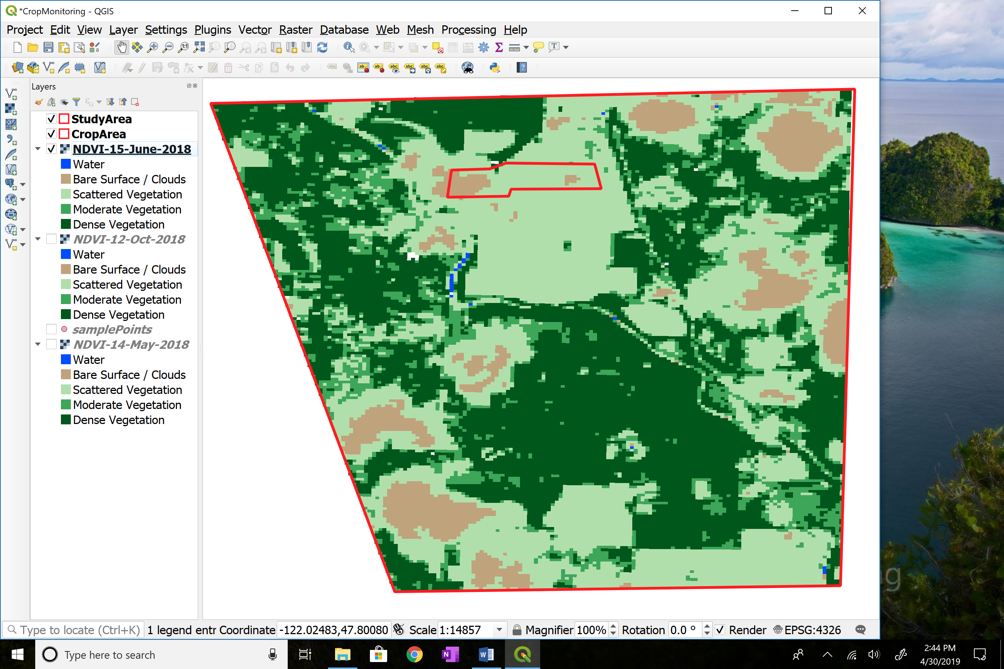

**Analysis**: Clouds cover the left end of field and one small area in right half of field

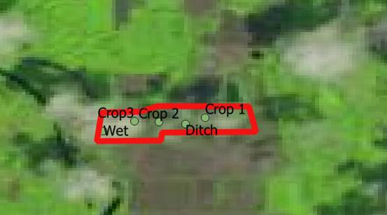

After verifying that the light brown areas are actually clouds, make a change to this layer’s color ramp

Select layer *NDVI-15-Jun-2018* > **Properties** **> Symbology**

To change the color *brown* to *white* (clouds)

Double click on the color *brown* in the **Color** column

Select the white area in color triangle of the **Change color** panel

In the **Label** column of the same row, delete the words *Bare surface*

Press **Tab** key

**OK**

(Optional) Chapter 21 describes one method of looking for cloud outlines in Landsat images. If you are interested, try this technique on the Landsat image for 15 June 2018.

**Step 4: Vegetation coverage is nearly 100% of field**

Complete the steps in Chapter 7, step 2 through Chapter 12, step 7 to analyze for NDVI for the date 8 July 2018

Note: Optionally, the NDVI images can be efficiently clipped and analyzed using the QGIS Model Builder saving time, effort and eliminating errors. See Chapter 19 to learn to create and run NDVI analysis using Model Builder.

**Analysis**: The amount of dark green vegetation has increased – about what we expected at this time in the growing season. However, the area on the left side of the image shows less vigorous growth; this was the water-covered area observed in April by the drone photos.

Chapter 10, Step 3 results

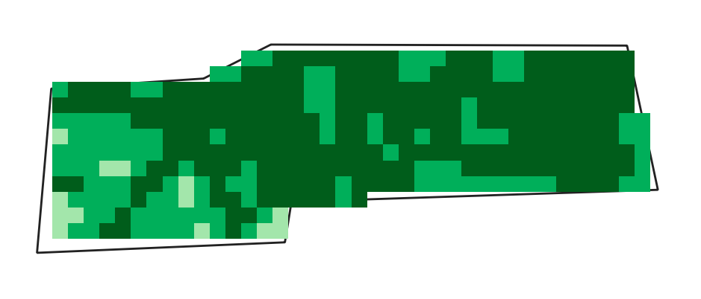

**Step 5: Corn grows tassels**

Complete the steps in Chapter 7, step 2 through Chapter 12, step 7 to analyze for NDVI for the date 24 July 2018

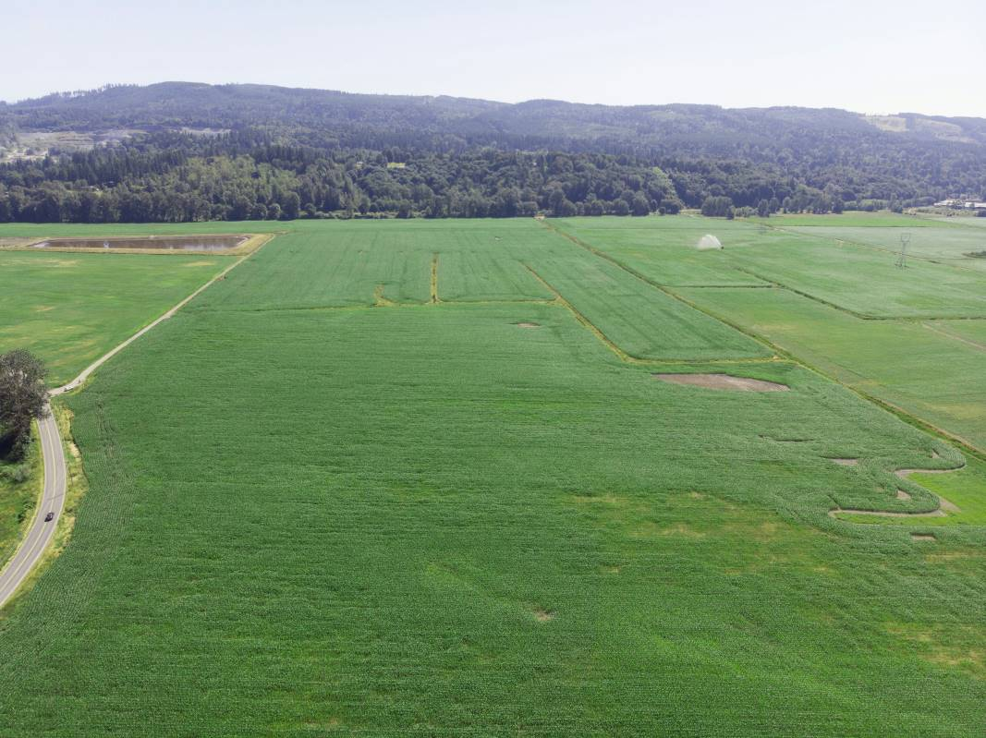

**Analysis**: The uniform dark green indicates healthy vegetation covers most of the field. Ground truthing shows that the corn has begun to develop tassels. The lighter green areas show lingering effects of the wet areas – what else could be causing retarded growth in these two areas?

Chapter 10, Step 3 results

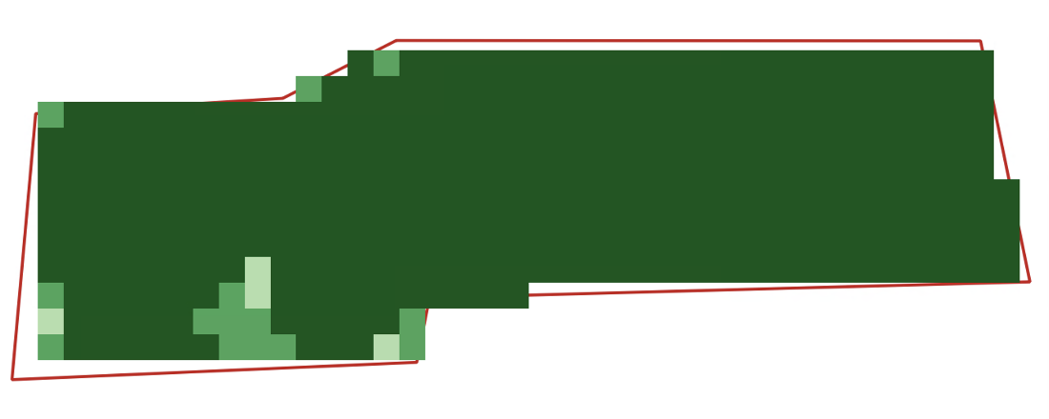

**Step 6: Maturing**

Complete the steps in Chapter 7, step 2 through Chapter 12, step 7 to analyze for NDVI for the date 3 Sep 2018

**Analysis:** Ground truthing determines that the corn has reached maximum height and is maturing. Some change is indicated by the scattered areas of lighter green.

Chapter 10, Step 2 results

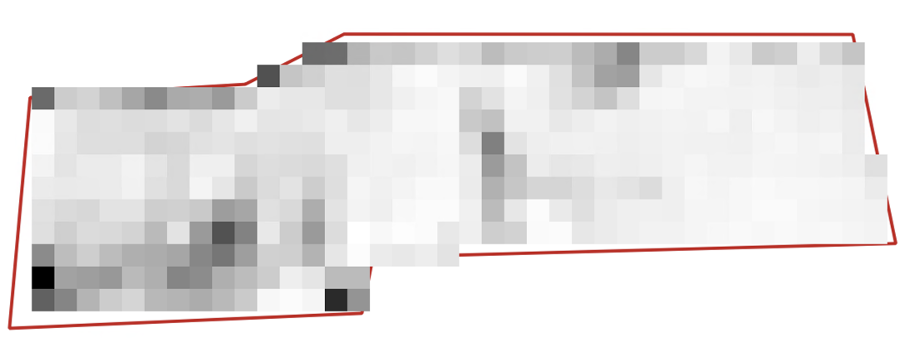

Chapter 10, Step 3 results

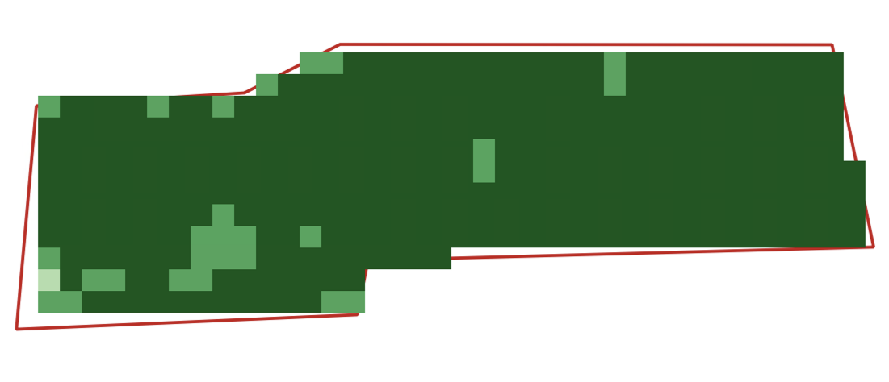

**Step 7: Drying out**

Complete the steps in Chapter 7, step 2 through Chapter 12, step 7 to analyze for NDVI for the date 19 Sep 2018

**Analysis**: The vegetation began drying out between 3 and 10 September. There has been little rain in the past two months. The goal for harvesting is for the corn to be 30-35% dry weight – in other words, when a sample of the corn is dried by heating, the liquid that evaporates is 65-70% of the undried corn’s weight.

Chapter 10, Step 2 results

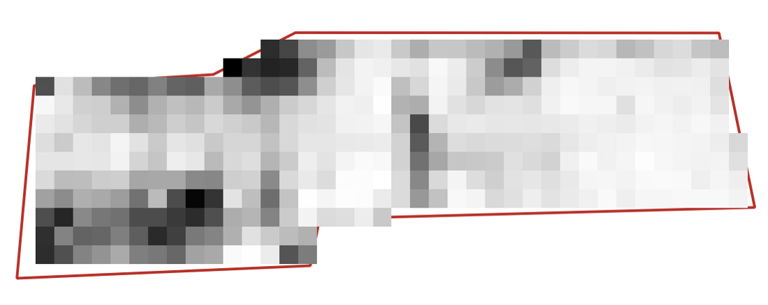

Chapter 10, Step 3 results

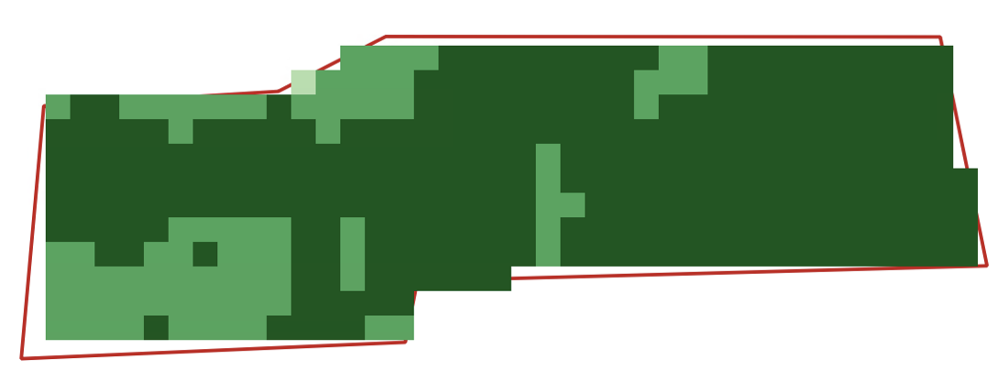

**Step 8: Harvest**

Complete the steps in Chapter 7, step 2 through Chapter 12, step 7 to analyze for NDVI for the date 10 Oct 2018

**Analysis**: Ground truthing verifies that the corn has now been cut and removed from the field. Some stalks and scattered leaves remain on the ground. The uniform light green color is what is expected for this condition.

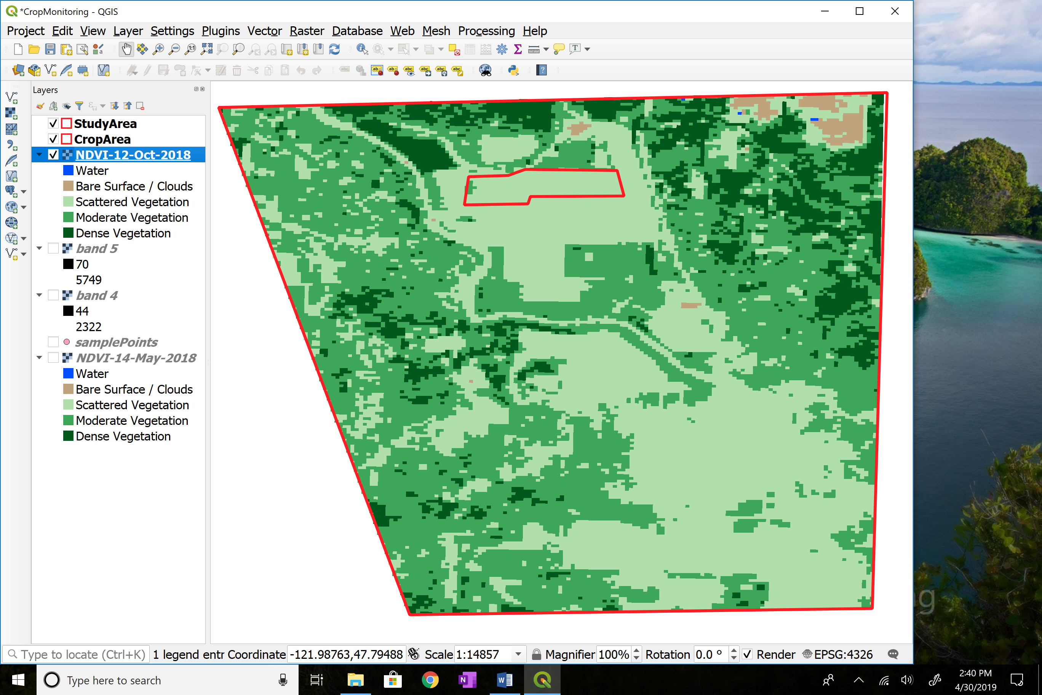

October 12, 2018 NDVI Result, it should look like this

## Chapter 13: Sampling Point Data

This chapter includes:

* Selecting sampling points for monitoring different crop maturity stages
* Viewing sampled data on time scale

Landsat images are made up of digital values measured for each 30x30 meter pixel. If we select some meaningful locations in our study area, we can monitor the change in pixel values at that location over time.

The pixel values we define will be helpful in setting the values for the NDVI color ramp such as was used in Chapter 10.

**Step 1 – Define the sampling points**

The locations we will monitor are:

* Three locations in the middle of crop area (presumably health vegetation)
* An area observed as “wet” in early spring
* Vegetation in a drainage ditch

**Step 2 – Add the points to QGIS map (this is a one-time action)**

Start **QGIS**

On the **QGIS** menu bar

Select **Project** > **Open**

Browse to folder *Monroe*

Select the **File Name** named *CropMonitoring*

**Open**

Add the following points to your QGIS map. Note that the coordinates are in UTM format – this is a required by the QGIS Plugin we will use..

ID,Type, Lon,Lat

1,Crop 1,-121.9893,47.8073

2,Crop 2,-121.9939,47.8069

3,Crop 3,-121.9963,47.8070

4,Wet,-121.9995,47.8062

5,Ditch,-121.9912,47.8067

Copy and paste the lines above into a text (.txt) file using Notepad

Name the file *SamplePoints* and save the file in the folder *Monroe.*

On the **QGIS** menu bar

Select **Layer**

Select **Add Layer**

Select **Add Delimited Text Layer**

In **File Name** box

Browse to in the folder *Monroe*

Select file *SamplePoints*

**Open**

On the **File Format** box

Select *CSV*

Select *0* in **Number of header lines to discard**

Select check markin box next to **First record has field names**

On the **Geometry Definition** line

Select *Point Coordinates*

In the **Geometry CRS** box

Select *Project CRS: WGS 84*

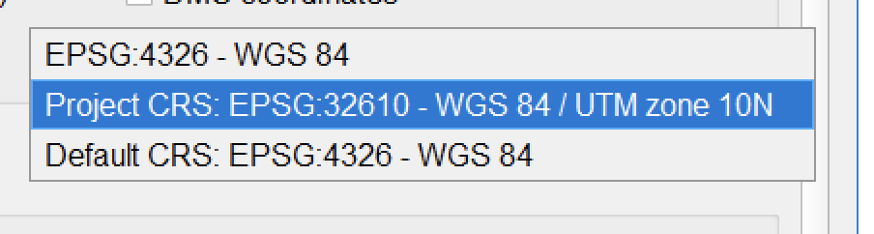

**Add**

**Close**

Label the points

Right click the layer *SamplePoints* > **Properties**

Select **Labels** tab

Select **Single labels** in topmost box

In **Label with** box, select *Type*

Click on **Background** tab

Check **Draw background** box

Click on **Placement** tab

Select **Around Point** circle

In **Distance** box, type *2*

**OK**

**Step 3 – Create an Excel spreadsheet**

Create an Excel spreadsheet with the following columns and rows (This is a **one-time action**)

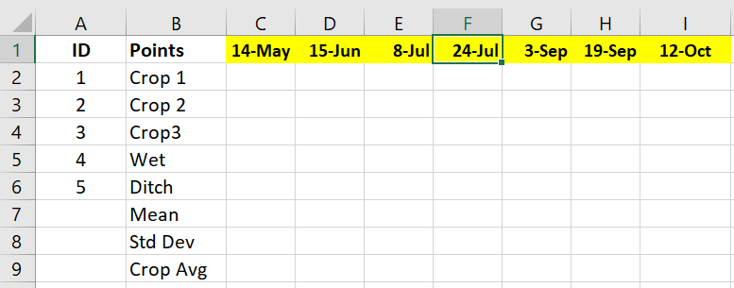

Save the Excel file in the folder *Monroe* with the file name *CropData*

**Step 4 – Enter the sample point values into the Excel spreadsheet**

Select the layer *NDVI-Crop-14-May-2018*

Check the box next to the layer *SamplePoints*

Click on the “information icon” 

In the lower left corner of the **Identify** **Feature** panel

In the **View** box, choose *Tree*

Move the cursor over the *Crop 1* sample point and left click

Enter the value from the field *Band1* in row 2 of the Excel table

Repeat for each sample point

The formula for cells in row 9 is the average of rows 2,3 and 4.

**Step 5 – Calculate the Mean and Standard Deviation for the Crop Area**

Right click on layer *NDVI-Crop-14-May-2018*

Select **Properties > Information**

Copy the value of **STATISTICS_MEAN**

Copy the value of **STATISTICS_STDDEV**

**OK**

Enter the *mean* and the *standard deviation* in the Excel table rows 7 and 8

**Step 6 – Graph the values for data visualization**

After processing the seven Landsat images in the case study, enter the data for each image following the pattern in Step 5. In Excel create a graph of the data in rows 7 and 9. When the case study is completed in Chapter 12, your graph should look similar to the following chart:

## Chapter 14: Final Analysis and Conclusions

The graph is about what we expected – no surprises. After the peak about Jul 23 the corn leaves begin to dry (no rain) and the graph lines decreases slightly. If data were plotted for every Landsat satellite pass (8 day intervals) the graph lines would be smoother.

## Chapter 16: Printing Maps and Images

This chapter includes:

* Learning how to prepare maps for distribution
* Creating template for the map
* Adding titles, legends and text boxes to the map

These instructions will help you create a template that will make it much easier to recreate a map with the same legend and symbology. This will save you a lot of time; you will not have to recreate the legend and symbology every time for each map.

**Step 1: Start QGIS**

Start **QGIS**

On the **QGIS** menu bar

Select **Project** > **Open Recent**

Browse to folder *Monroe*

Select **File Name =** *CropMonitoring*

**Open**

**Step 2: Create a new template for printing the map**

Select the map layers you want to appear on the printed map.

In the **Layers Panel** on the left of the screen, uncheck layers you don’t want to print.

Select any layer whose name begins with *NDVI-Crop*

Position the map in the screen as you want it to appear when printed.

(optional) Select the **Zoom In** icon 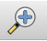 and, while holding down the left click button, draw a rectangle around the area that you want to appear when the map is printed.

On the **QGIS** menu bar

Select **Project** > **New Print Layout**

Type *NDVI-Crop* in the **Create print layout Title** box

**OK**

On the side menu bar select the **Adds a new Map to the layout** icon 

Hold down the left click button, draw a rectangle around the area where you want to the map to appear

If the map does not appear the way you want,

Go back to the main map to adjust the view

Return to **Layout Manager**

If the map is not in the position you want

Click **Move item content 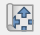icon**

Left click on the map and drag to reposition

If the map does not render clearly or sharply

Click on the **Refresh view** icon 

To keep the map from being accidentally moved, lock its position

Click anywhere inside the map

Right click inside the map

Select **Item Properties**

In the **Layers** section, check mark **Lock Layers**

Select menu option **Layout**

Select **Save as template**

Browse to folder = *Monroe*

**File** **Name** = *NDVI-Crop (add date)*

**Save**

**Step 3: Add Legend:**

A useful feature for formatting the legend titles is the “wrap” feature. You can define a “wrap character” and insert it in the legend title to force the text following the wrap character to move onto the next line.

On the menu bar

Select **Add Item** > **Add Legend**

Click in the map at the position where you want the title to appear

In **Height** box, type *20* or a height of your choice

**OK**

Right click with the cursor inside the **Legend** box > **Item Properties**

In **Main Properties** section

In **Title** box type *Coverage*

Define a **Word wrap** character (one-time only)

In **Item Properties**

Select **Wrap Text On** box and type any character, such as @

Open **Legend Items** section

Click to remove the *check mark* in the **Auto Update** box

Click on any layer you do not want to appear in the legend

Select **Delete ** icon

Open **Fonts** section

Click on **Title** **Font**

**Font** > *Arial* > **Font** **Style** > *Bold* > **Size** *24 >* **OK**

Click on **Subgroup** **Font**

**Font** > *Arial* > **Font** **Style** > *Bold* > **Size** *16 >* **OK**

In **Item Font** select a font of your choice> **OK**

Resize the frame of the text box by dragging the edges to fit text

Drag the legend to the lower right corner of the map, then use the arrow keys for fine-tuning position adjustments

**Step 4: Add Scale Bar:**

On the menu bar,

Select **Add Item** > **Add Scale Bar**

Click in the map at the position where you want the title to appear

In **Height** box, type *20* or a height of your choice

**OK**

In the **Item Properties** section

In **Scalebar** **units** box, select *Meters*

In the **Label unit multiplier** box,type *1.0*

In the **Label for units** box, type *meters*

In **Segments**, select *Left 0* and *Right 3*

Check **Frame** and **Background** boxes

Resize the frame of the text box by dragging the edges to fit text

If you have not already done so, drag the scale bar to the lower left corner of the map, then use the arrow keys for fine-tuning position adjustments

**Step 5: Add Map Title:**

On the menu bar

Select **Add Item** > **Add Label**

Click in the map at the position where you want the title to appear

In **Height** box, type *20*

**OK**

In the **Item Properties** section

In the **Main Properties** box type an appropriate title for the map, such as:

NDVI – Corn Field – *date* 2018

Select **Font**

**Font** > *Arial* > **Font** **Style** > *Bold* > **Size** *28 >* **OK**

Select **Horizontal alignment** = *Left*

Uncheck **Frame** and **Background** boxes

Resize the frame of the text box by dragging the edges to fit text

**Step 6: Add Data Source Labels:**

On the menu bar

Select **Add Item** > **Add Label**

Click in the map at the position where you want the text box to appear

In **Height** box, type *20*

**OK**

In the **Item Properties** section

In the **Main Properties** box type an appropriate title for the data sources, and add a list of them:

*Data Sources:*

*- USGS*

Select **Font**

**Font** > *Arial* > **Font** **Style** > *Bold* > **Size** *12 >* **OK**

Select **Horizontal alignment** = *Left*

Check **Frame** and **Background** boxes

Position the Data Source text box in the lower center of the map

Resize the frame of the text box by dragging the edges to fit text

**Step 7: Add Date and Author Label:**

On the menu bar

Select **Add Item** > **Add Label**

Click in the map at the position where you want the text box to appear

In **Height** box, type *20*

**OK**

In the **Item Properties** section

In the **Main Properties** box type your name and the date the map was created

Select **Font**

**Font** > *Arial* > **Font** **Style** > *Bold* > **Size** *10 >* **OK**

Select **Horizontal alignment** = *Left*

Check **Frame** and **Background** boxes

You can resize the frame of the text box by dragging the edges to fit text

Position the date label box in any part of the map.

**Step 8: Add North Arrow**

On the menu bar

Select **Add Item** > **Add Picture**

Left click in the lower right corner of the map at the position where you want the North Arrow to appear -> **OK**

On the right panel select **Main** **Properties** tab

Click on **Search** **directories** section to expand

Choose the north arrow you prefer from icon table

In the **Placement** dropdownbox, select *Top Left*

Uncheck the **Background** box

You can resize the frame of the text box by dragging the edges to fit text

Position the north arrow box above the scale bar.

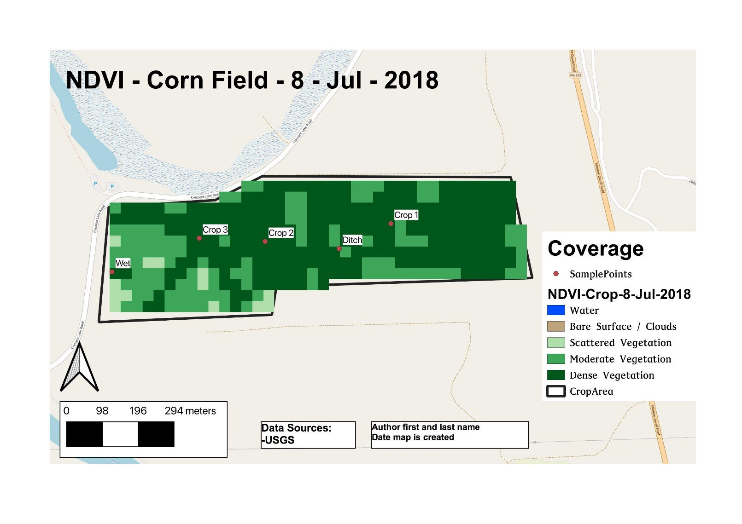

**Step 9: Create image file of map**

Select menu option **Layout**

Select **Export as Image**

Browse to folder *14-May-2018* (or other folder)

In **Save as type** choose *JPG format (*.* *Jpeg)*

Name file with an appropriate name

**Save > Save**

**Step 10: Print your map from the saved image**

Select menu option **Layout** > **Page Setup**

Choose **Orientation =** *Landscape*

**OK**

Select menu option **Layout**

Select **Print**

Select printer

**Print**

**Step 11: Save as Template:**

Select menu option **Layout** > **Save as Template**

Browse to folder = *Monroe*

**File name** = *NDVI-Crop*

**Save** > **Yes**

Select menu option **Layout** > **Close**

**Step 12: Save Project**

On the **QGIS** menu bar

Select **Project** > **Save**

On the **QGIS** menu bar

Select **Project** > **Exit QGIS** > **Save**

## Chapter 17: Telling the Story

This chapter includes:

* Creating a PowerPoint of the story the data is telling
* Preparing spoken presentation

PowerPoint outline

Introduction

Purpose and significance of the study

Materials and Methods

Study area

Data resources

Methodology

Results

Status at baseline

Change over time

Discussion

Expectations

Timing

Anomalies

Conclusions

Acknowledgements

Guidelines on speaking presentation

# Part 5: Useful Tools

## Chapter 18: Creating a Study Area Using Google Earth

This chapter includes:

* Instructions for creating a study area using Google Earth features

Now that you have some map layers in your GIS project file, you may want to study a different area of special interest. Let’s define a new study area that is a subset of the full image area.

**Step 1: Run the Google Earth program and locate your area of interest**

Install **Google Earth** from google website (if needed)

Start **Google Earth**

Navigate to the general area you wish to define as your study area.

**Step 2: Set the Google Earth coordinate system to match your QGIS project coordinate system**

The coordinate system you use for your QGIS project must be the same as the coordinate system defined in Google Earth so that the file created in Google Earth will register correctly when you bring it into your QGIS project.

Select menu item **Tools** > **Options**

Select the **3D View** tab

In the **Show Lat/Long** box

If you plan to work with Landsat images

Choose the **Universal Transverse Mercator** button

If you plan to work with GADM administrative boundary maps

Choose the **Decimal Degrees** button

**Apply > OK**

**Step 3: Draw a polygon around your study area**

Select the A**dd Polygon**  icon

In the **Name** box, type *StudyAreaGE*

Move the cursor outside the polygon parameters box to the upper left corner of your desired study area. You may need to move the parameters box out of the way by left clicking in the title bar, then, while holding the left click button down, drag the box to an unused position on your screen.

Position the cursor at the upper left corner of your study area and left click

Move the cursor to the upper right corner of your area and left click

Move the cursor to the lower right corner of your area and left click

Move the cursor to the lower left corner of your area

If your study area is not a rectangle, you can left click on as many points as you need

**OK**



The polygon will look similar to this

**Step 4: Save your study area polygon as a KML file**

On the menu **File** > **Save** > **Save Place As**

browse to folder named *Monroe*

type **File Name** = *StudyAreaGE*

select **File Type** = *KML*

**Save**

**Step 5: Add the KML file of your study area to QGIS project**

Start **QGIS**

On the **QGIS** menu bar

Select **Project** > **Open**

Browse to the folder where your project is located

Select your project file

**Open**

On the **QGIS** side tabs, select **Add Vector Layer** icon 

For **Dataset**, browse to folder where your project is located

In the box to the right of **File Name** select file type *KML*

Select the file named *StudyAreaGE*

**Open** > **Open**

**Step 6: Create a shapefile of your study area**

Right click the layer *StudyAreaGE*

Select **Save as** option

Choose **Format** = *ESRI shapefile*

In **Encoding**, choose *Layer CRS*

Browse **CRS**

Select in the **Coordinate Reference Systems of the World** box the same reference system that you are using for your reference map project > **OK**

Click to put a check in the box **Add saved file to map**

In **Save As** box, browse to folder where your project is located

In **File Name** box type, *StudyAreaGE >* **Save**

**OK**

Right click on the layer *StudyAreaGE*

Select **Zoom to Layer**

Right click the layer *StudyAreaGE* > **Properties**

Select **Style** tab

Click on **Simple fill**

For **Fill style,** select *No Brush*

For **Border color,** select *black* > **OK**

For **Border style,** select *Solid Line*

For **Border width,** type *1*

**Apply** > **OK**

Right click the layer *StudyAreaGE* for the KML file

Select **Remove > OK**

**Step 7: Save the Project**

The new shapefile named *StudyAreaGE* defining your study area has already been saved in folder *Monroe*.

On the **QGIS** menu bar

Select **Project** > **Save**

On the **QGIS** menu bar

Select **Project** > **Exit QGIS**

## Chapter 19: Adding Photos to a Map

This chapter includes:

* How to add photos to a map

If you have photos from your ground truthing work, you can add the photos to your map **if** the photos contain geotagging information.

Mobile phone settings required to enable geotagging of photos:

iPhone:

One way to know if an iPhone is set to geotag photos is:

open **Photos** app **> Albums > Places** and see if the photo of interest is displayed. If you see the photo in **Places**, then the photo was geotagged

**Settings > Privacy > Location Services** (set to *on*) > **Camera** > Select *While using*

Android phones:

One way to know if an Android phone is set to geotag photos is to:

open **Files** app > **Images** > **Camera** > select your photo > **Info** and see if the location shows up.

If you see a small map with the appropriate location, then the photo was geotagged

**Camera** app > **Settings** > Save Location (set to on)

If “Allow Camera to access this device’s location?” shows up, select *Allow*

**Step 1: One-time activation of a Plugin**

On the **QGIS** menu bar

Select **Plugins > Manage and Install Plugins**

Select **ImportPhotos > Install plugin > Close**

**Step 2: Select photo folder**

On the **QGIS** menu bar

Select **Plugins**

Select **ImportPhotos > Import Photos**

In **Input folder location** browse to your photos folder

Click on **Select Folder** button

In **Output file location** browse to the folder *Monroe*

In the **File Name** box, type *PhotosGeoLoc*

**Save**

**OK > OK > Close**

**Step 3: View photos**

Click on **Photo** icon 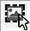on toolbar

or

On the **QGIS** menu bar

Select **Plugins**

Select **Import Photos > Click Photos**

Double left-click any photo icon on the map to view the photo

## Chapter 20: Using Model Builder

This chapter includes:

* Definition of Model Builder
* Instructions for creating the model
* Instructions for running the model

Clipping Landsat images and performing NDVI analysis requires performing QGIS tasks in order and repetitively. We can use the QGIS Model Builder to organize the tasks and perform the steps again and again using only a few keystrokes.

Begin by clipping the Landsat images. Once the clip function is finished, then perform the NDVI analysis.

**Step 1: Building the model**

Start **QGIS**

On the **QGIS** menu bar

Select **Project** > **New**

On the **QGIS** menu bar

Select **Processing > Graphical Modeler**

In the **Name** box, type *Clip and NDVI*

In the **Group** box, type *Monroe*

In the lower left corner, select the tab **Inputs**

Click on **Raster Layer** and drag it onto the main screen

In the box **Parameter Name**, type *Band4*

Check the box **Mandatory**

**OK**

Repeat that step changing the name to *Band5*

In the lower left corner, select the tab **Algorithms**

Click on the plus sign to the left of **GDAL**

Click on the plus sign to the left of **Raster Extraction**

Drag **Clip Raster by Mask** **Layer** onto the main screen

In **Description** box, type *Clipped* *Band4*

In **Input Layer** box, select *Band4*

In **Mask Layer** box

Browse to folder *Monroe*

Select *CropArea.shp*

**Open**

In the **Assign a specified nodata value….** box

Type *0*

In the **Match the extent of the clipped raster…** box

Select *Yes*

**OK**

Repeat that step changing the names to *Band5*

Click on **Save Model As** icon on top left of screen

Browse to the folder *Landsat*

In the **Name** box, type *Clip2NDVI*

**Save**

Now we will use the clipped file as input to the NDVI calculation.

*Note: I tried using the algorithm* ***Raster Calculator*** *under* ***Raster Analysis*** *but could not get it to work. The following method is not the most efficient, but it works.*

Click on the plus sign to the left of **SAGA**

Click on the plus sign to the left of **Raster Calculus**

Drag **Raster Difference** onto the main screen

In the box named **A**, select *…ClippedBand5*

In the box named **B**, select …*ClippedBand4*

In the box **Parent Algorithms** select **Select All > OK**

**OK**

Drag **Rasters Sum** onto the main screen

In the box named **Grids**

Select the two bands that start with *Clipped (mask) …*

In the box **Parent Algorithms**

Select *ClippedBand4 and ClippedBand5*

**OK > OK**

Drag **Raster Division** onto the main screen

In the box named **Dividend**

Select the band that start with *Difference …*

In the box named **Divisor**

Select the band that start with *Sum …*

In the box named **Quotient** type *NDVI-Crop*

In the box **Parent Algorithms** select *Raster Difference* and *Raster Sum*

**OK > OK**

Click on **Save** icon on top left of screen

Your model should look similar to this:

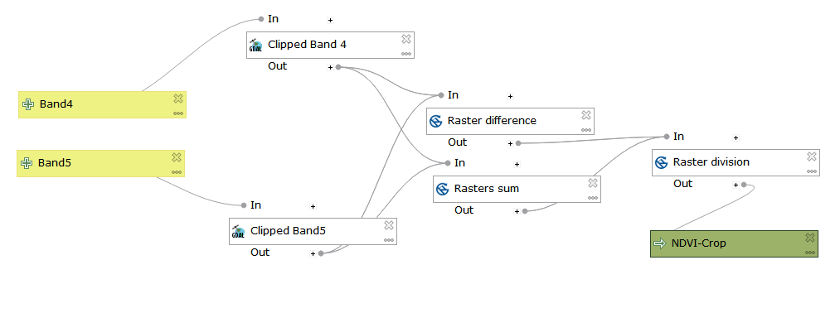

Click on the **X** in the upper right corner to exit Model Builder

**Step 2: Running the model**

Start **QGIS**

On the **QGIS** menu bar

Select **Project** > **Open**

Browse to folder *Monroe*

Select **File Name** *CropMonitoring*

**Open**

On the **QGIS** side bar select the **Add Raster Layer** icon 

Browse to the folder *19-Apr-2018* in folder *Landsat*

Select the file ending in *sr-band4* (band 4)

Select the file ending in *sr-band5* (band 5)

**Open** **> Add**

**Close**

On the **QGIS** menu bar

Select **Processing > Graphical Modeler**

Click on the folder icon 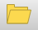 in the upper left corner

Browse to the folder *Landsat*

Select the Model Builder file named *Clip2NDVI*

**Open**

Click on the **Run model arrow** on the menu bar

In the box named *Band4* select the raster image ending in *..sr_band4*

In the box named *Band5* select the raster image ending in *..sr_band5*

**Run**

The process may take up to a minute depending on the speed of your computer.

When the calculations are complete, **Close**

Return to your main QGIS screen and you should see your NDVI analysis of the crop area.

Apply the color ramp style to view the vegetation categories.

## Chapter 21: Looking for Clouds

This chapter includes:

* Analyze Landsat images for clouds

One of the problems with Landsat images is the presence of clouds which obscure the earth’s surface. Several techniques for overcoming this problem have been developed but are beyond the scope of this document. However, the following process will help identify the areas that are obscured by clouds. This chapter is a work in process. There are some problems with the plugin which, hopefully, will be resolved in the times ahead.

Install the Plugin **Cloud Mask**

*As of 13 Nov 2018, this plugin causes QGIS 3.4/6 to crash. But it works well in QGIS 3.2*

*This plugin is not working in QGIS 3.2 for Landsat Level 2 images downloaded using EarthExplorer.*

Start **QGIS**

On the **QGIS** menu bar

Select **Plugins > Manage and Install Plugins**

Select **Cloud Masking > Install plugin > Close**

Download Landsat image -- all bands - 14 June 2018 – Level 1 only

On the **QGIS** menu bar

Select **Plugins > Cloud mask for Landsat products > Cloud Masking**

Move cloud masking panel to middle of screen by dragging heading bar

Select **Open and Load** tab

Browse for MTL format file in folder *15-Jun-2018*

**Open**

Select **Load** button

Select **Load Stack** button

Select **Filters and Mask** tab

Select **FMask** check box

Select **Water** check box

Select **Generate Mask** button

“*QGIS Not responding*” message is normal – be patient—a long delay at 70% is normal. This is heavy computation time – this step can take as much as 10-12 minutes. Wait for blue wheel to stop spinning. The word *DONE* will display next to the **Generate Mask** button

Result will be a new layer named *Cloud Mask*

*Note: as of 13 Nov 2018* ***selected area*** *and* ***shape area*** *options cause QGIS to error – so don’t use those options*

Select **Apply and Save** tab

Click on **Save Mask** button > **Save**

In **Select output file for save result** box

Click **Select** button

Browse to Jun-14 folder

In **File Name** box type *FMaskClouds*

**Save**

Click **Apply mask** button

Close **Cloud mask** panel

Select layer *Study Area* – zoom to layer

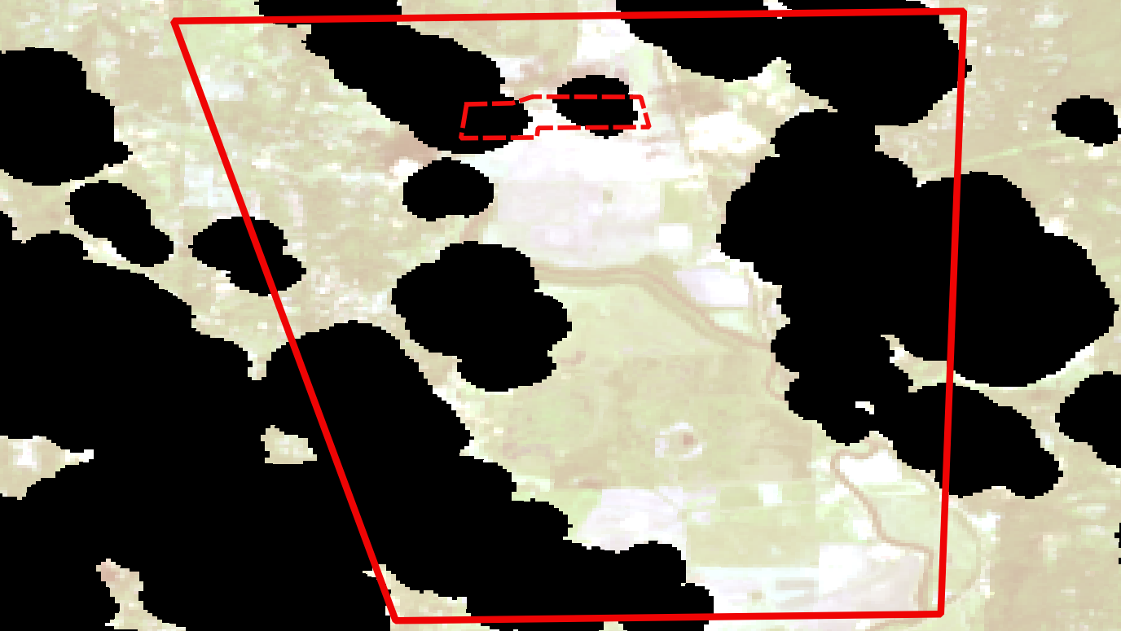

Save QGIS project

Convert raster layer *Cloud Mask* to vector layer

Select menu option **Raster > Conversion > Polygonize**

In **Input Layer** box, select the raster with file name ending in …*Enmask.tif*

In **Vectorized** box, select **Save to file**

browse to folder 14-Jun-2018

change file type to SHP

in file name box

Type *VectorClouds*

**Save**

Click on **Run in background** button

**– this took about 10 minutes for entire image – clip image ??**

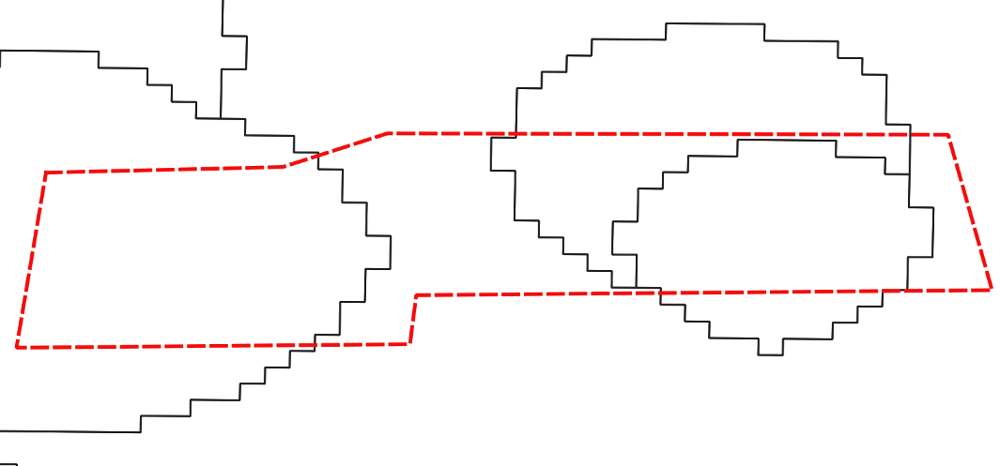

Use vector layer to clip and save as TIF

# Appendixes:

## Appendix A: References

1. Introduction to Remote Sensing, Fifth Edition, Campbell and Wynne, The Guilford Press, 2011
2. GIS Ag Maps, http://www.gisagmaps.com/

## Appendix B: NDVI ColorRamps

**Text for *NDVIColorRamps***

# QGIS Generated Color Map Export File – Landsat Level-1

INTERPOLATION:DISCRETE

0.07,0,76,255,255,Water

0.16,191,163,124,255,Bare Surface / Clouds

0.25,177,223,171,255,Scattered Vegetation

0.4,61,166,89,255,Moderate Vegetation

0.99,0,87,27,255,Dense Vegetation

# QGIS Generated Color Map Export File – Landsat Level-2

INTERPOLATION:DISCRETE

0.0,0,76,255,255,Water

0.2,191,163,124,255,Bare Surface / Clouds

0.7,177,223,171,255,Scattered Vegetation

0.8,61,166,89,255,Moderate Vegetation

0.99,0,87,27,255,Dense Vegetation

How color ramps work in QGIS

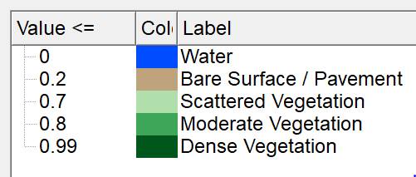

When the value falls between two numbers, the color of the higher number in the range will be rendered.

To learn how these values were selected, read the section entitled “Developing a Color Ramp” in Chapter 11, Ground Truth Sampling.

## Appendix C: Landsat Image Specifications

Write some Text here

|  |  |  |  |  |
| --- | --- | --- | --- | --- |
| **Date** | **Path** | **Row** | **Level** | **Image ID** |
| 19 Apr 18 | 47 | 26 | 1 | LC08_L1TP_047026_20180419_20180502_01_T1 |
| **Crop condition:** *untilled and unplanted*  **Analysis:** | | | | |

|  |  |  |  |  |
| --- | --- | --- | --- | --- |
| **Date** | **Path** | **Row** | **Level** | **Image ID** |
|  | 47 | 26 | 1 |  |
| **Crop condition:**  **Analysis:** | | | | |

# Index

7-Zip 10

Calculator 34

Clip 33, 49

Clouds 48, 78

Color ramp 35, 45, 82

EarthExplorer 21

GADM 11

GLOVIS 22

Google Earth 45, 68

Ground truthing 43

Interpretation 29

KML file 69

Landsat 21

Landsat 8 31

LandsatLook 22

Legend 60

Model Builder 49, 74

NDVI 31

NIR 33

North arrow 63

Scale bar 61

Study area 68

Title 61

USGS website

EarthExplorer 21

LandsatLook 22